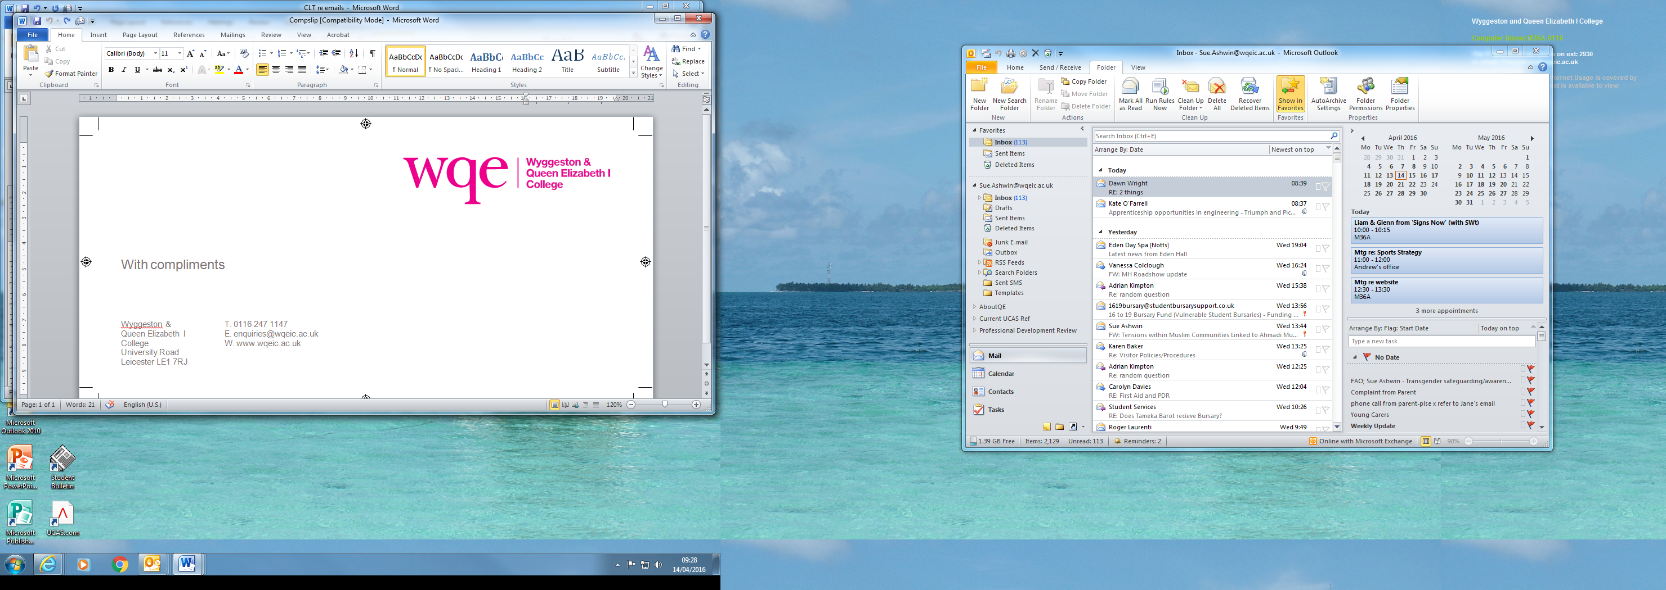

**Candidate Consent Form for Access to Online Scripts – Summer 2024**

|  |  |  |  |
| --- | --- | --- | --- |
| **Centre Name**: | Wyggeston & Queen Elizabeth I College | | |
| **Centre Number**: | 25270 | **Candidate Number**: |  |
| **Candidate Name**: |  | | |

|  |
| --- |
| I hereby grant permission for my script(s) from the exams listed below to be accessed online at Wyggeston and Queen Elizabeth I College. |

|  |  |  |  |
| --- | --- | --- | --- |
| **Awarding Body** | **Subject** | **Paper Reference** | **For Exams Use Only** |
|  |  |  |  |
|  |  |  |  |
|  |  |  |  |
|  |  |  |  |
|  |  |  |  |
|  |  |  |  |
|  |  |  |  |

|  |  |
| --- | --- |
| **Student Signature**: ________________________________ | **Date**: _____________________ |
|  |  |