VIRTUAL PARENT & CARER’S EVENING
25th January and 30th January 2024
L3 (year 1)

January 2023

Dear Parent/Carer,

You are being invited by the College to attend a Virtual Parent/Carers’ event, on either the afternoon/evening of Thursday 25th January 5.00pm – 8.00pm or, Tuesday 30th January 3.30pm – 6.30pm to discuss your child’s progress with subject teachers. Following positive feedback from users, we have decided to continue using the online ‘school cloud’ system, you are therefore not required to attend in person.

If you wish to participate, please follow the link below to log on to the system and make appointments with the staff you wish to see. The system will allow appointments of a maximum of eight minutes in length. You will receive an automatic email with a copy of the appointments and a link to connect you on the evening.

Please refer to the attachment for a guide on how to use the booking system which will open from Tuesday 16th January at 2.00pm. Alternatively, and in exceptional circumstances we are happy to assist you in booking your appointment by telephoning 0116 2471147 and speaking to Lynn, Jovita or Afnan. We will require you to give your child’s name, ID number, your name, your email address and telephone number. We can only use the parental email we currently have on our system, any updates to this information must be managed by the student with their PPM before we can make an appointment.

Staff will make every effort to adhere strictly to appointments and we ask that you also co-operate in this respect. Issues which require lengthy discussions are not easily dealt with on evenings such as this, so if there is a need for a fuller discussion, we can arrange a further appointment at a more appropriate time.

If you make appointments but are unable to attend on the day, please phone us on (0116) 247 1147 and speak to Lynn, Jovita or Afnan so that we can let staff know.

We look forward to joining you on-line, on Thursday 25th January or Tuesday 30th January.

Yours faithfully,

Mr David Morgan
HEAD OF STUDIES

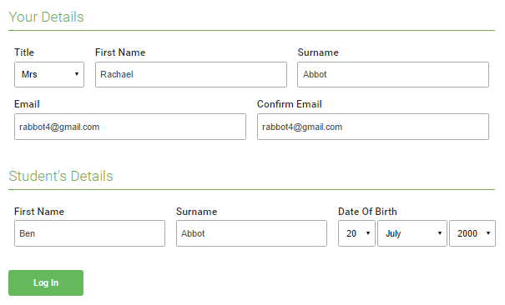 | Step 1: Login  Browse to https://wqe.parentseveningsystem.co.uk/  Fill out the details on the page then click the Log In button.  A confirmation of your appointments will be sent to the email address you provide.
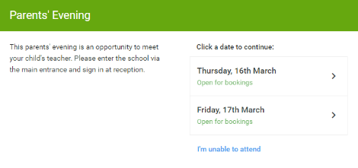 | Step 2: Select Parents’ Evening  Click on the date you wish to book.  Unable to make the date listed? Click I'm unable to attend.
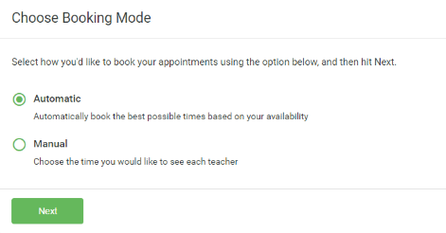 | Step 3: Select Booking Mode  Choose Automatic if you'd like the system to suggest the shortest possible appointment schedule based on the times you're available to attend. To pick the times to book with each teacher, choose Manual. Then press Next.  We recommend choosing the automatic booking mode when browsing on a mobile device.
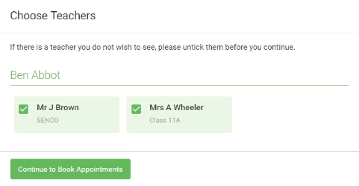 | Step 4: Choose Teachers  If you chose the automatic booking mode, drag the sliders at the top of the screen to indicate the earliest and latest you can attend.  Select the teachers you’d like to book appointments with. A green tick indicates they’re selected. To de-select, click on their name.
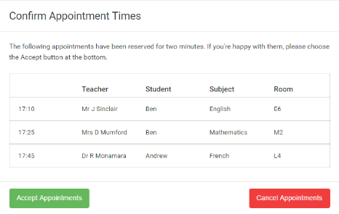 | Step 5a (Automatic): Book Appointments  If you chose the automatic booking mode, you'll see provisional appointments which are held for 2 minutes. To keep them, choose Accept at the bottom left.  If it wasn’t possible to book every selected teacher during the times you are able to attend, you can either adjust the teachers you wish to meet with and try again, or switch to manual booking mode (Step 5b).
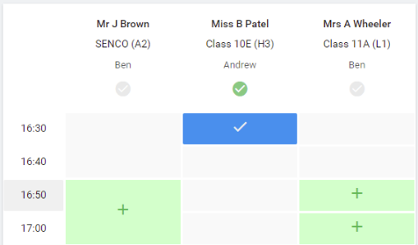 | Step 5b (Manual): Book Appointments  Click any of the green cells to make an appointment. Blue cells signify where you already have an appointment. Grey cells are unavailable.  To change an appointment, delete the original by hovering over the blue box and clicking Delete. Then choose an alternate time.  Once you’re finished booking all appointments, at the top of the page in the alert box, press click here to finish the booking process.
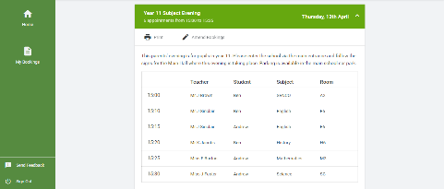 | Step 6: Finished  All your bookings now appear on the My Bookings page. An email confirmation has been sent and you can also print appointments by pressing Print. Click Subscribe to Calendar to add these and any future bookings to your calendar.  To change your appointments, click on Amend Bookings.

