Welcome to Product Design. I hope you are ready for a diverse, creative, exciting and productive experience over the next two years. To kick things off– I have set the following task, which must be completed for, and bought to your first Design lesson.

To be done on A3 paper (this is not the same as 2 A4 pieces taped together) – Portrait or Landscape format:
Go into your kitchen at home– find what you think is an example of interesting product de- sign (sometimes the small things are the most interesting). You need to fully describe this product through drawing and identify your thinking and reasons for choosing it. You need to use multiple drawings from a range of viewpoints. You may need to zoom in on specific details. You will need to consider how large you draw, how you lay out the sheet, whether or not to use colour. Look at examples of product design drawing sheets to guide you on presentation.
Type ‘product design sketching’ into Pinterest for inspiration.
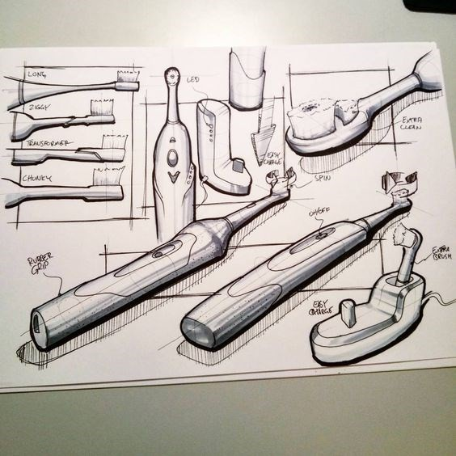
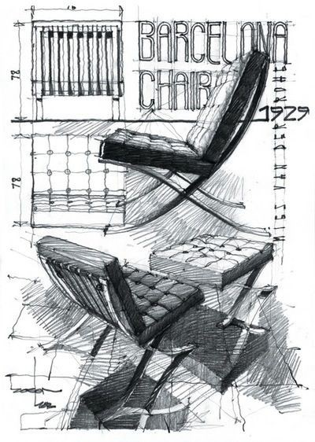
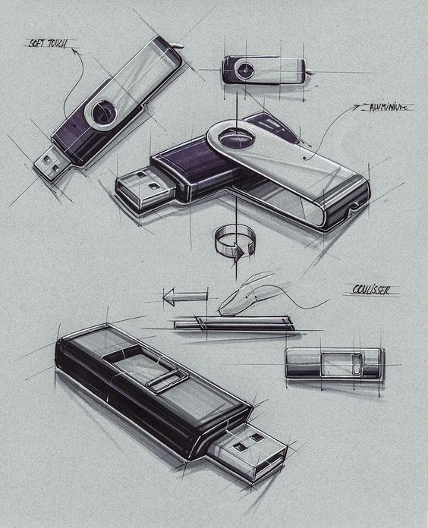

I need to see what you are capable of, how well you follow instruction and your ability to research so try your best.

