Name:

Physics homework
Use your GCSE notes/book to help you answer these questions
The nucleus:
1. Which particles are in the centre of an atom?
- A. protons and electrons.
- B. neutrons and electrons.
- C. neutrons and protons.
- D. protons, neutrons and electrons.
2. What is the name of the centre part of an atom, and what orbits around this?
 | Centre part | In orbit
A | A nucleus | protons
B | B nucleole | electrons
C | C nucleus | electrons
D | D nucleole | protons

Q3-6. Which of these particles
A Electron, B Proton, C Neutron or D None of these…….
3. ..has a negative charge.
4. ..has a mass of 1 atomic unit and a positive charge.
5. ..has a neutral charge.

Here is a diagram of an atom of Beryllium. It has the symbol:
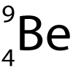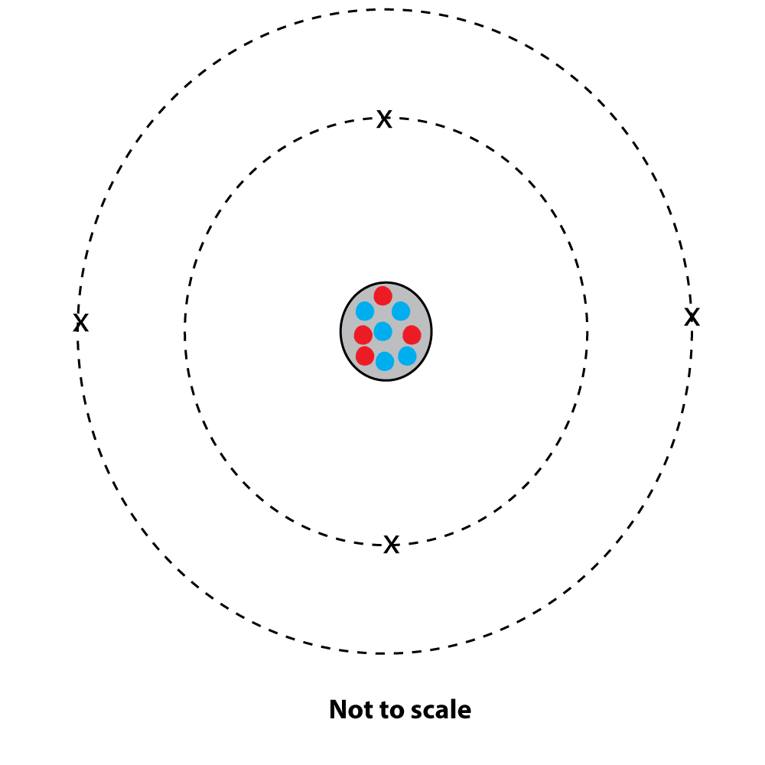
6. What does the top number represent?
- A. The number of protons.
- B. The number of protons plus electrons.
- C. The number of neutrons.
- D. The total mass of the nucleus.
7. What does the bottom number represent?
- A. The number of protons.
- B. The number of protons plus electrons.
- C. The number of neutrons.
- D. The total mass of the nucleus.
8. The symbol for the radioactive isotope strontium 90 is shown here. How many protons (p) and neutrons (n) does it have?
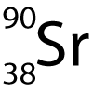
- A. 90 p, 90 n
- B. 38 p, 90 n
- C. 52 p, 38 n
- D. 38 p, 52 n

Waves:
What region of the electromagnetic spectrum (Radio, microwaves, Infra red, Visible light, Ultra Violet, Gamma rays)…..
3. has the most energy?
4. is used in remote controls for televisions?
5. can be used to kill cancer cells?
Which colour of visible light in the spectrum...
6. Has the longest wavelength?
7. Has the highest frequency?
8. All electromagnetic waves have similar properties. Which one of these is NOT a property of electromagnetic waves?
- A). All travel at the same speed
- B). They all can pass through a vacuum
- C). They can all be reflected
- D). They all have a longer wavelength than sound waves.
9. Which one of these is a longitudinal wave?
- A). Water (surface) waves
- B). Sound wave
- C). Radio wave
- D). X ray wave
11. Which of these is the correct term for a wave where the individual particles move at right angles to the direction of the wave energy transfer?
- A). Transverse
- B). Longitudinal
- C). Refracted
- D). Propagated
12. Which of these arrows correctly shows the amplitude and wavelength?
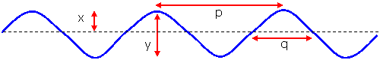
 | Amplitude | Wavelength
A). | x | p
B). | y | p
C). | x | q
D). | y | q

