WQE is one of the largest sixth form providers in England; a large twin-site college, centrally located in the city of Leicester. The College’s most recent Ofsted inspection was in March 2022 where we received a Grade 2 (Good) for Overall Effectiveness.
WQE aims to develop young professionals to be qualified to Level 3 and ready to progress to Level 4. We recognise that our students join us from a diverse range of backgrounds and are responsive to individual needs to support all students in a successful transition from school to Post-16 education.
We actively encourage you start engaging with us at this early opportunity by completing the induction task below and submitting it to your class teacher during your first lessons in September
The task outlined below will give you an idea of what this Level 3 course involves.

Resources required

- Laptop (or pen and paper)
- Internet (desirable not essential)
- www.brianmac.co.uk
- www.theeverleaner.com
- Newspapers
- TV news reports

Assignment details

Complete the eight tasks. There is an extension activity at the end should you wish to complete the assessment questions.

Task One – The Skeletal System

Label the skeleton using the bones below.

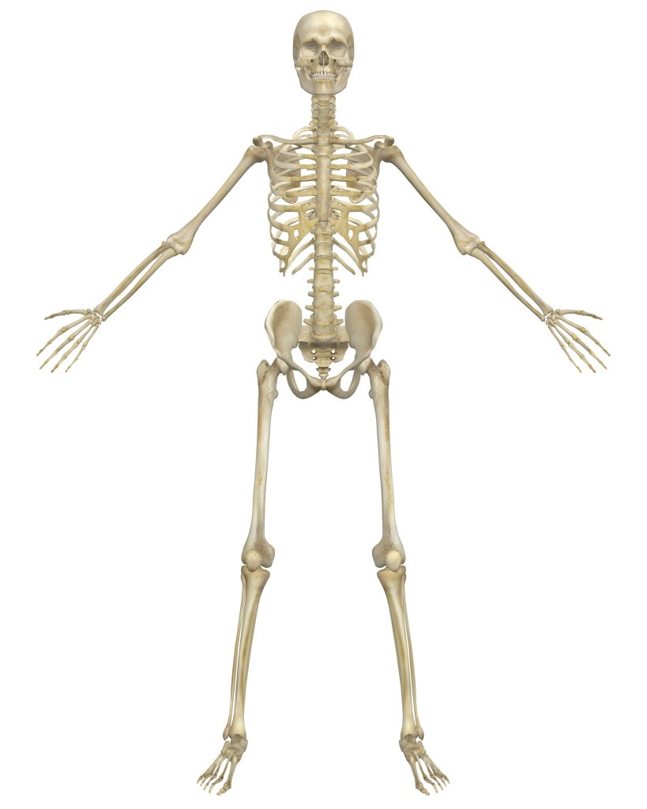

Axial skeleton, i.e.  - Cranium  - Sternum  - Ribs  - Vertebral Column  - Cervical Vertebrae  - Thoracic Vertebrae  - Lumbar Vertebrae  - Sacrum  - Coccyx | Appendicular skeleton, i.e.  - Scapula  - Clavicle  - Humerus  - Ulna  - Radius  - Carpals  - Metacarpals  - Phalanges | - Ilium  - Ischium  - Pubis  - Femur  - Patella  - Tibia  - Fibula  - Talus  - Tarsals  - Metatarsals

Task Two – The Vertebral column

Name/label the bones of the vertebral column & add any other relevant detail. Consider the structure and function.

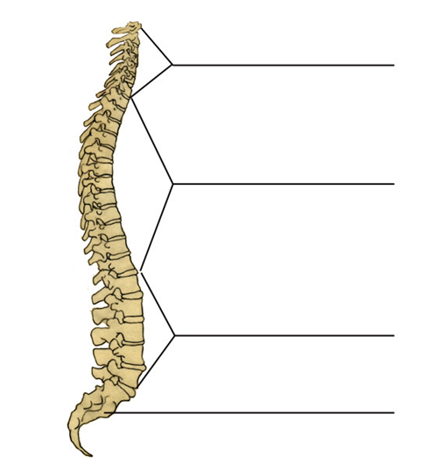

Task Three – Quick review:

- Name three bones of the appendicular skeleton

- Name three bones of the axial skeleton

- What are the five key functions of the skeleton?

Task Four – Bones and joints of the skeleton

Research and answer the following questions:

- Give one function of a long bone and a different function of a flat bone.

- Aside from long and flat bones, name the other three types of bone

- Are the vertebrae: (tick the correct answer)

- Fixed joints
- Slightly moveable joints
- Freely moveable joints

- Give the other name for freely moveable joints

- Apart from ‘Hinge’ joint, name the other five different types of freely moveable joint.

Task Five – The Muscular system

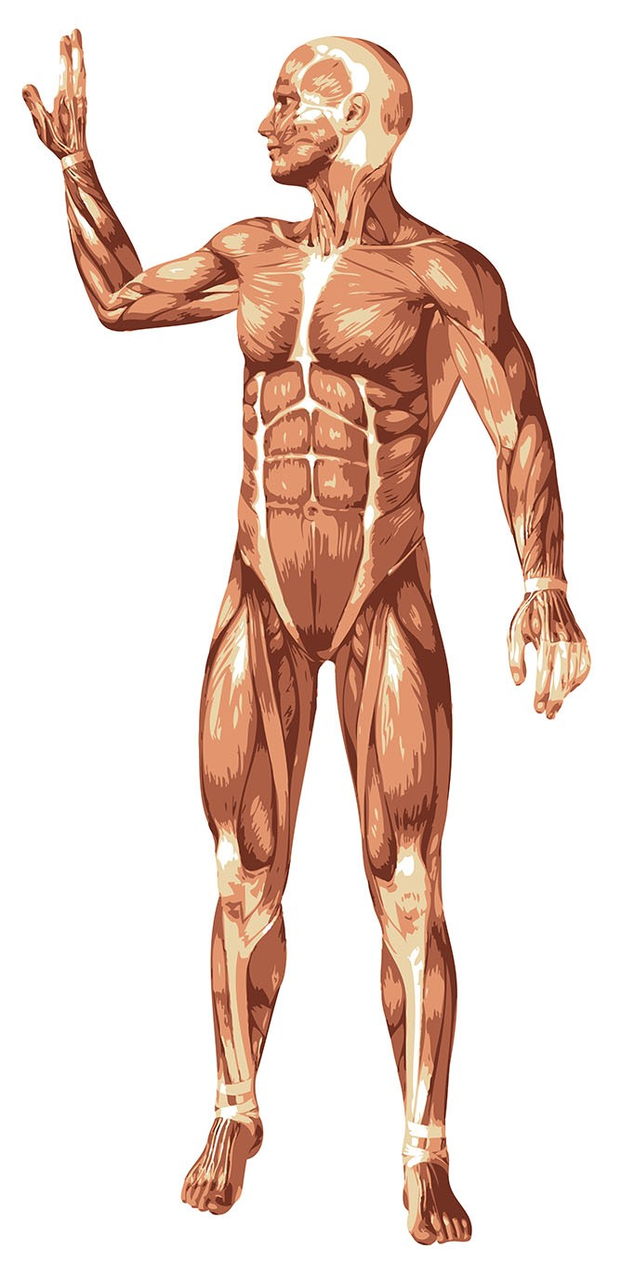
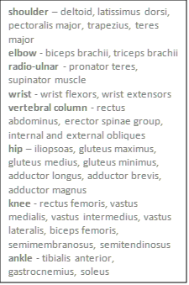

Label the muscle diagram below using the muscles that operate around each of the named joints.

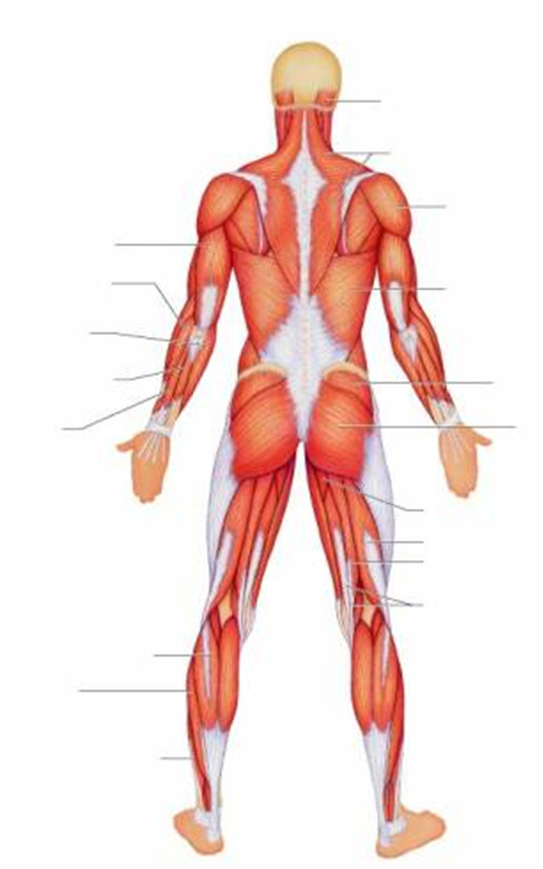

Task Six – The muscle

Answer the following questions:

- What is the difference between a ligament and a tendon?

- There are three different muscle fibre types. Identify their structure, function and the type of activity in which they would dominate

Name | Structural characteristics (how they’re made) | Functional characteristics (what job they do) | Typo of activity
Slow oxidative

(Type I)

Fast oxidative glycolytic (FOG)
(Type IIa)

Fast twitch glycolytic
(FTG)
(Type IIb or IIx)

Task Seven - The three Energy Systems

Research and complete the table below

:

 | ATP-PC/Alactic System | Lactic Acid System | Aerobic System
Type of Reaction (Aerobic or Anaerobic)
Chemical/Substrate or Food fuel (what is broken down)
Amount of ATP produced
By-products
Additional Info

Task Eight – Sociological issues in sport

Write a 500 word report on the impact of Coronavirus on sport and physical activity in the UK. You may want to consider some, none, or all of the below bullet points:

- What sports/physical activities had their participation reduced, and why?
- What sports/physical activities saw an increase in participation and why?
- Restrictions on and differences between grassroots and elite sport
- Impact on training and competition
- The impact on mental health of restrictions in sport.

Task Nine - Optional Extension Activity – Assessment practice questions

These are from the A level textbook we use and have been taken from previous exam papers.

