[ O*]

Print your name here:

Sign your name here:
Your printed name is a literal version of your name whilst your signature is a symbolic one, reflecting on this, your first assignment is to produce TWO creative self-portraits, one with you in the picture (the literal), and one without you in the picture (the symbolic). This will require some careful thought and consideration. What will you include, or not include?
How do you capture your personality in one image? Do you focus on your interests? or a quirky trait you may have? What defines you as a person? And how do you photograph it? Is it a still life? An abstraction? Or a metaphor?
For Each Portrait:
- Come up with an idea
- Shoot a minimum of 18 photographs based on this idea – print them out small on one sheet of A4.
- Select your best image from these 18 – print this as a separate image, 6x4 inches in size
- Write a paragraph explaining your idea and why you chose that image as your best.
- Write down 5 things you like about your best image.
- Write down 5 ways that you might improve it.
Make it visually interesting!
Inspiration
www.robertweingarten.com/portrait_unbound.html www.flickr.com/photos/jasontravis/sets/72157603258446753 www.iso.500px.com/creative-self-portraits www.npg.org.uk/learning/digital/portraiture/self-image/basic-materials-page-4
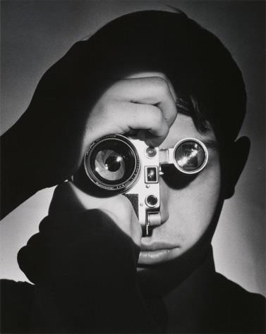
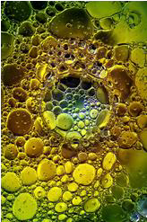
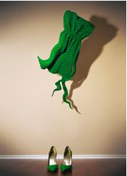
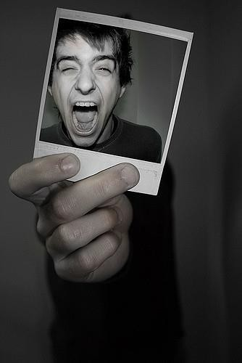

Bring all your work to your first lesson

