Photography Introductory Task
Welcome

Here’s your introductory task to be completed ready for our first lesson.

Introduction
Welcome to GCSE Photography. To help you get started with your coursework we are setting you a short task to get you thinking about your subject.

The Task
- Using still life as a genre, investigate the work of Edward Weston.
- Study his work and write some comments about one of your favourite images.
- Comment on aspects such as the lighting, colour, framing, distance from photographer, composition and overall meaning.
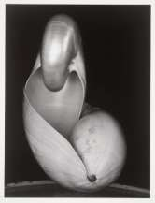
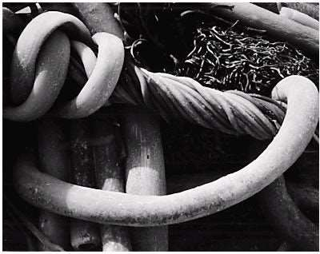
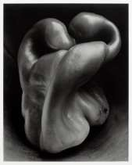

- Photograph one or two objects from different and uncommon viewing angles.
- Produce 20 images of the object(s) that would be difficult to identify due to the viewpoints you have chosen. Consider how you perceive the object.

- Present your images in a way that suits them. If you do not have access to a printer, you may save work in Word or as a Power Point Presentation.

- Cameras – If you have your own SLR camera /DSLR, please remember to bring it in on the first lesson; do not worry if you do not have one! You can use your phone camera for this task.

- Due: To be submitted at your first lesson in September

- Expected Time Commitment: The work set should take you approximately 3 hours.

Be creative and enjoy!
Jacqueline.

