Dear A-level Mathematics student,

Welcome to WQE Mathematics department. We would like every student who wishes to study A-level Mathematics to feel confident and well prepared for the course. We understand that during this COVID-19 pandemic all GCSE exams were cancelled, and you may not have covered some topics or may be a little unsure about the algebra skills required for A level mathematics. We have put together a set of resources to learn, practice and test your progress before lessons formally begin in early September.

1. Use the website link below to work through each module of work, these are specifically aimed for students like you who are moving from GCSE to A Level and there is enough there to practice the techniques as well as to extend and challenge for those who want to delve a bit further. ***Practice is essential in Mathematics.*** We do **NOT** expect you do everything in the module but to pick and choose which areas **YOU** need to work on.

If you feel that you need extra guidance / help we have added videos from Corbett maths as well as practice questions taken from GCSE papers. No login required for either site.

[https://amsp.org.uk/resource/gcse-alevel-transition-resources](http://corbettmaths.com/2013/05/27/graphical-inequalities-part-1/)

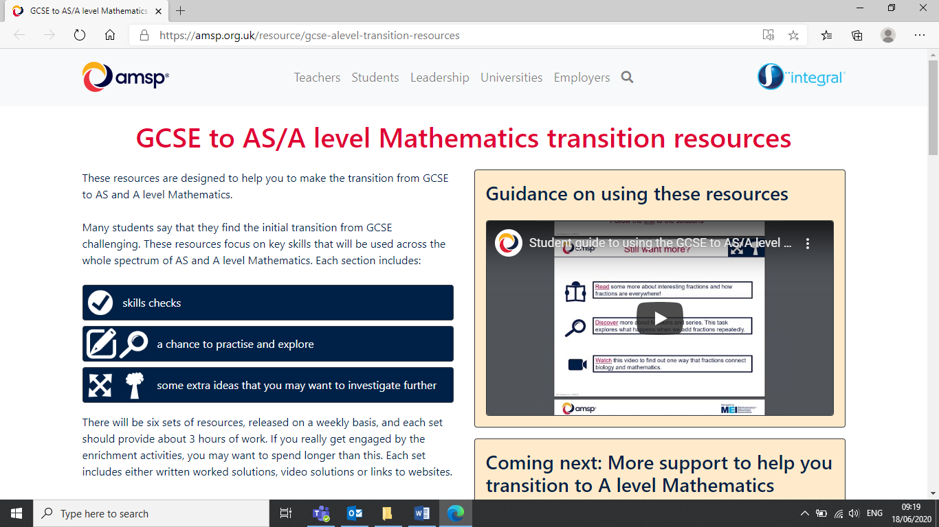

Worth watching the video before you start

Icons help to navigate your learning

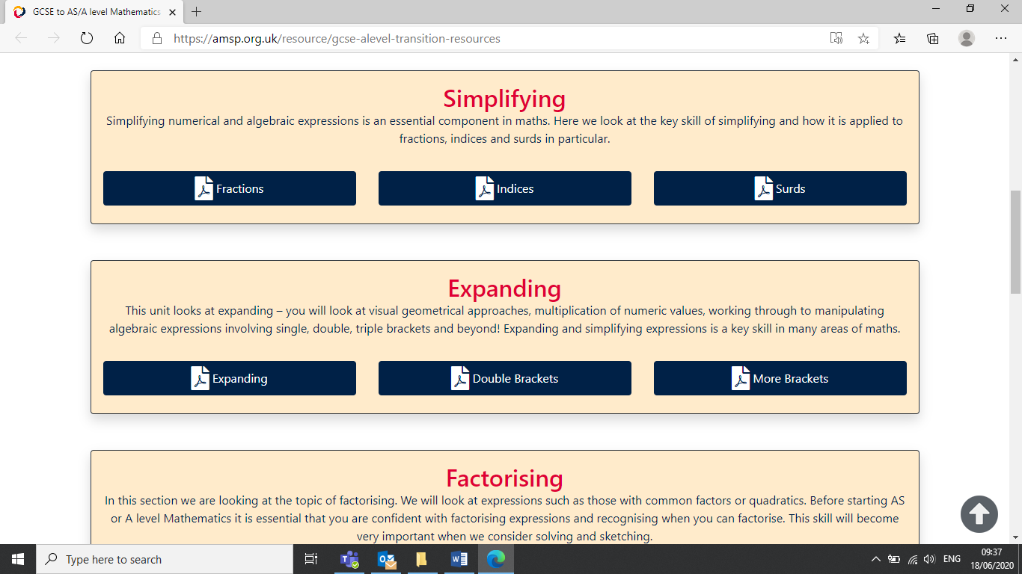

By working through the tasks below you have shown perseverance, organisation, and time management skills, as well as a heap of maths skills so feel CONFIDENT to begin your journey through A level Mathematics.

These are examples of the first two modules listed in the teaching scheme below

You have time between enrolment and when teaching begins on 6th September, and we hope you enjoy using these resources and become proactive in your learning to become successful in this subject.

By following these instructions (*another great skill*) set out in this document you are giving yourself the best start to your A level Mathematics course.

*Good luck*

*The Mathematics Team*

|  |  |  |  |  |  |
| --- | --- | --- | --- | --- | --- |
|  | **Module** | **Topic from AMSP** | **Corbett maths Videos** | **Corbett maths** | **Done?** |
| 1 | Simplifying | Fractions | Algebraic fractions: multiplication   [Video 23](https://corbettmaths.com/2017/09/25/quadratic-graphs-completing-the-square/)  Algebraic fractions: simplifying   [Video 24](http://corbettmaths.com/wp-content/uploads/2013/02/drawing-quadratics-pdf.pdf) | [Practice Questions](http://corbettmaths.com/2013/05/07/simultaneous-equations-linear-and-quadratic/)  [Practice Questions](https://corbettmaths.com/wp-content/uploads/2013/02/laws-of-indices-algebra-pdf.pdf) |  |
|  |  | Indices | Indices: fractional     [Video 173](https://corbettmaths.com/wp-content/uploads/2013/02/graphical-inequalities-pdf1.pdf)  Indices: laws of   [Video 174](https://corbettmaths.com/wp-content/uploads/2013/02/cubic-graphs-pdf.pdf)  Indices: negative     [Video 175](http://corbettmaths.com/2013/05/11/surds-addition/) | [Practice Questions](https://corbettmaths.com/wp-content/uploads/2013/02/reciprocal-graphs-pdf.pdf)  [Practice Questions](http://corbettmaths.com/2013/04/20/drawing-graphs-using-gradient-and-intercept/)  [Practice Questions](http://corbettmaths.com/2013/03/03/fractional-indices/) |  |
|  |  | Surds | Surds: intro, rules, simplifying     [Video 305](http://corbettmaths.com/2013/03/13/laws-of-indices-algebra/)  Surds: Addition and Subtraction [Video 306](http://corbettmaths.com/2013/11/17/exponential-graphs/)  Surds: rationalising denomin [Video 307](http://corbettmaths.com/2012/12/23/drawing-graphs-using-xy-tables/)  Surds: expanding brackets     [Video 308](http://corbettmaths.com/2013/05/11/surds-expanding-brackets/) | [Practice Questions](https://amsp.org.uk/resource/gcse-alevel-transition-resources)  [Practice Questions](http://corbettmaths.com/2013/06/23/drawing-quadratics/)  [Practice Questions](http://corbettmaths.com/wp-content/uploads/2013/02/expanding-two-brackets-pdf1.pdf)  [Practice Questions](https://corbettmaths.com/wp-content/uploads/2013/02/drawing-linear-graphs-pdf.pdf) |  |
| 2 | Expanding | Expanding | Algebra: expanding brackets   [Video 13](http://corbettmaths.com/2013/01/19/simplifying-algebraic-fractions/) | [Practice Questions](https://corbettmaths.com/wp-content/uploads/2013/02/surds.pdf) |  |
|  |  | Double Brackets | Algebra: expanding two brackets   [Video 14](https://corbettmaths.com/wp-content/uploads/2013/02/surds.pdf) | [Practice Questions](https://corbettmaths.com/wp-content/uploads/2013/02/drawing-linear-graphs-pdf.pdf) |  |
|  |  | More Brackets (*Only do this one if you have time)* | Algebra: expanding three brackets   [Video 15](http://corbettmaths.com/2013/03/24/negative-indices/) | [Practice Questions](https://corbettmaths.com/wp-content/uploads/2013/02/algebraic-fractions.pdf) |  |
| 3 | Factorising | Factorising | Factorisation: quadratics   [Video 118](https://corbettmaths.com/wp-content/uploads/2013/02/algebraic-fractions.pdf) | [Practice Questions](http://corbettmaths.com/wp-content/uploads/2013/02/fractional-negative-indices-pdf1.pdf) |  |
|  |  | Further Factorising | Factorisation: quadratics harder   [Video 119](http://corbettmaths.com/2013/12/23/changing-the-subject-video-7/)  Factorisation: splitting the middle    [Video 119a](http://corbettmaths.com/2013/12/27/expanding-three-brackets-video-15/) | [Practice Questions](http://corbettmaths.com/wp-content/uploads/2013/02/fractional-negative-indices-pdf1.pdf) |  |
|  |  | Completing the Square | Factorisation: difference of 2 squares [Video120](http://corbettmaths.com/2013/02/06/factorising-quadratics-1/) | [Practice Questions](https://corbettmaths.com/wp-content/uploads/2013/02/factorising-quadratics.pdf) |  |
| 4 | Rearranging | Rearranging | Algebra: changing the subject    [Video 7](http://corbettmaths.com/2013/05/11/surds/)  Algebra:changing the subject advanced   [Video 8](https://corbettmaths.com/wp-content/uploads/2013/02/surds.pdf)  Algebra: collecting like terms     [Video 9](http://corbettmaths.com/2013/05/11/rationalising-denominators/)  Equations: solving    [Video 110](http://corbettmaths.com/2012/08/24/solving-equations/)  Equations: cross multiplication     [Video 112](http://corbettmaths.com/wp-content/uploads/2013/02/expanding-brackets-pdf.pdf) | [Practice Questions](http://corbettmaths.com/2012/08/24/solving-equations-with-letters-on-both-sides/)  [Practice Questions](http://corbettmaths.com/2013/12/28/changing-the-subject-advanced-video-8/)  [Practice Questions](https://corbettmaths.com/wp-content/uploads/2013/02/surds.pdf)  [Practice Questions](http://corbettmaths.com/2013/12/23/expanding-brackets-video-13/)  [Practice Questions](http://corbettmaths.com/2013/05/19/equations-cross-multiplication/) |  |
|  |  | Rearranging and Factorising | Equations: letters both sides   [Video 113](http://corbettmaths.com/2013/12/23/expanding-two-brackets-video-14/) | [Practice Questions](http://corbettmaths.com/2013/02/07/factorising-quadratics-2/) |  |
|  |  | Rearranging and Fractions | Equations: involving fractions    [Video 111](http://corbettmaths.com/2013/01/19/multiplying-algebraic-fractions/)  Equations: fractional advanced    [Video 111a](http://corbettmaths.com/wp-content/uploads/2013/02/expanding-three-brackets-pdf.pdf) | [Practice Questions](http://corbettmaths.com/2013/02/08/difference-between-two-squares/)  [Practice Questions](https://corbettmaths.com/wp-content/uploads/2013/02/simultaneous-equations-pdf.pdf) |  |
| 5 | Equations | Linear Equations | Simultaneous equations (elimination) [Video 295](http://corbettmaths.com/wp-content/uploads/2013/02/equations-pdf.pdf)  Simultaneous equations (substitution, both linear)   [Video 296](https://corbettmaths.com/2019/03/26/splitting-the-middle-term/)  Simultaneous equations (advanced) [Video 298](https://corbettmaths.com/wp-content/uploads/2013/02/factorising-quadratics.pdf) | [Practice Questions](https://corbettmaths.com/wp-content/uploads/2013/02/equations-fractional-pdf.pdf)  [Practice Questions](https://corbettmaths.com/wp-content/uploads/2013/02/factorising-quadratics.pdf)  [Practice Questions](http://corbettmaths.com/wp-content/uploads/2013/02/changing-the-subject-pdf.pdf) |  |
|  |  | Quadratic Equations | Quadratics: solving (factorising)  [Video 266](https://corbettmaths.com/wp-content/uploads/2013/02/exponential-graphs-pdf.pdf)  Quadratics: formula     [Video 267](http://corbettmaths.com/2013/12/28/collecting-like-terms-video-9/)  Quadratics: solving (completing the square)  [Video 267a](http://corbettmaths.com/2013/12/29/completing-the-square-video-10/) | [Practice Questions](https://corbettmaths.com/wp-content/uploads/2013/02/cross-multiplication-pdf.pdf)  [Practice Questions](https://corbettmaths.com/wp-content/uploads/2013/02/simultaneous-equations-non-linear-pdf.pdf)  [Practice Questions](http://corbettmaths.com/wp-content/uploads/2013/02/changing-the-subject-advanced-pdf.pdf) |  |
|  |  | Other Equations *(Trig- Only do this one if you have time)* | |  |  |
| 6 | Sketching | Linear Sketching | Linear graphs: drawing (xy table) [Video 186](http://corbettmaths.com/wp-content/uploads/2013/02/equations-pdf.pdf)  Linear graphs:drawing using y=mx+c [Video187](https://corbettmaths.com/wp-content/uploads/2019/02/Collecting-like-terms.pdf)  Linear graphs: (across one method) [Video 188](https://corbettmaths.com/wp-content/uploads/2013/02/solving-quadratics-factorising-pdf1.pdf)  Graphs: line graphs     [Video 160](https://corbettmaths.com/wp-content/uploads/2013/02/equations-fractional-advanced-pdf.pdf) | [Practice Questions](http://corbettmaths.com/2013/06/22/sketching-quadratics/)  [Practice Questions](http://corbettmaths.com/2013/05/25/algebraic-equations/)  [Practice Questions](http://corbettmaths.com/2015/12/07/equations-involving-algebraic-fractions-advanced/)  [Practice Questions](https://corbettmaths.com/wp-content/uploads/2013/02/simultaneous-equations-pdf.pdf) |  |
|  |  | Quadratic Sketching | Quadratic graphs: drawing     [Video 264](http://corbettmaths.com/2013/05/22/line-graphs/)  Quadratic graphs: sketching using key points      [Video 265](http://corbettmaths.com/2013/03/05/simultaneous-equations-elimination-method/)  Quadratic graph (completing the square)    [Video 371](http://corbettmaths.com/2013/05/07/solving-simultaneous-equations-by-substitution/) | [Practice Questions](https://corbettmaths.com/wp-content/uploads/2013/02/equation-of-a-line-pdf.pdf) |  |
|  |  | Other Sketching  *(Only do this one if you have time)* | Inequalities: graphical y>a or x>a  [Video 180](https://corbettmaths.com/wp-content/uploads/2013/02/line-graphs-pdf.pdf)  Inequalities: graphical y>x+a   [Video 181](http://corbettmaths.com/2013/04/20/finding-equation-of-a-linear-graph/)  Types of graph: cubics     [Video 344](https://corbettmaths.com/wp-content/uploads/2013/02/quadratic-formula-pdf.pdf)  Types of graph: exponential     [Video 345](http://corbettmaths.com/2013/05/03/solving-quadratics-by-factorising/)  Types of graph: reciprocal     [Video 346](http://corbettmaths.com/2013/04/24/quadratic-formula/) | [Practice Questions](https://corbettmaths.com/wp-content/uploads/2013/02/graphical-inequalities-pdf1.pdf)  [Practice Questions](http://corbettmaths.com/2013/05/27/graphical-inequalities-part-2/)  [Practice Questions](https://corbettmaths.com/2016/08/07/cubic-graphs/)  [Practice Questions](https://corbettmaths.com/wp-content/uploads/2013/02/completing-the-square-pdf1.pdf)  [Practice Questions](http://corbettmaths.com/2013/10/24/reciprocal-graphs/) |  |

1. Now that you have reviewed your skills, complete the following assessment which **MUST be handed in at the beginning of your first Mathematics lesson.**

You **MUST** show all your working, and you are **not allowed to use a calculator**!

You will be awarded marks for **presentation**, so make sure you write out your solutions on **A4 lined** or **squared paper**, **underline** your answers, and write your **name** and **student** number on your work.

**1.** Simplify these expressions.

**a**  **(1 mark)**

**b**  **(1 mark)**

**c**  **(3 marks)**

**2** Solve  **(2 marks)**

**3** Find the value of *x*.

 **(2 marks)**

**4 a** Write  in the form , where *a* is an integer. **(1 mark)**

**b** Expand and simplify . **(2 marks)**

**c** Simplify  giving your answer in the form , where *a*, *b* and *c* are rational numbers. **(3 marks)**

**5** The area of a triangle is given as cm2.

The base of the triangle is cm, and the perpendicular height is cm.

Find the values of *p* and *q*. **(4 marks)**

**6** Expand and simplify these expressions.

**a**  **(1 mark)**

**b**  **(2 marks)**

**c**  **(3 marks)**

**7** Fully factorise these expressions.

**a**  **(1 mark)**

**b**  **(1 mark)**

**8** Solve these equations.

**a**  **(1 mark)**

**b**  **(2 marks)**

**c**  **(2 marks)**

**9** Solve these pairs of simultaneous equations.

**a**  **(3 marks)**

**b**  **(4 marks)**

**10** Solve these inequalities.

**a** 7*x* − 6 ⩽ 8 **(1 mark)**

**b** 3*x* + 2 ⩾ 7*x* − 4 **(2 marks)**

**c** > 0 **(2 marks)**

**Total marks 44 + 1 mark for presentation**