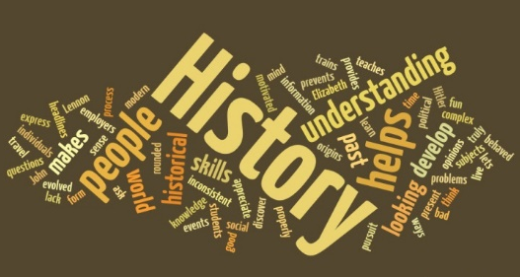
Welcome to History! Over the next few days, we want you to begin to think about some important concepts, including the very nature of history itself. Complete the following tasks and bring them with you to your first lesson.
Key Term
Key Words. The following are all basic terms that you will encounter in your study of History. It is therefore vital that you understand their meaning. Produce a detailed definition for each terms, with historical examples where possible
Definition
1. Democracy

2. Monarchy

3. Republic

4. Constitution

5. Censorship

6. Authoritarian

7. Revolution

8. Emancipation

9. Civil War

10. Poverty

The Nature of History
We now want to see if you can demonstrate some crucial historical skills. Type your answers to both tasks and print them off to hand in.
What is history?
Write a definition of History:

Essay Task:
‘The study of history is so important that it should be a compulsory A Level subject ‘.
Explain why you agree or disagree with view.

Write an essay to answer this question. It should be handwritten and should be two to three sides of A4 in length, hand-written.

- Include an introduction to open your essay, setting you which arguments you will consider and introducing your viewpoint.

- Then include a range of reasons for and against this view. You could consider different arguments why History is a useful subject and how much validity each argument has. Examples include:

- History is fascinating and full of exciting stories.
- History helps us understand people and societies.
- History allows us to learn from the mistakes of the past.
- History is important in understanding our own identity.
- History is essential for good citizenship.
- History provides a framework to explore moral issues.

- You might also want to discuss whether any subject should be compulsory at A-level, and include arguments for and against these.

- Support each argument with specific examples of events, people and developments from History to provide evidence for your point.

- Include a conclusion that sums up your arguments and gives your overall view.

The American Historical Association website provides a range of useful examples to help support your essay:
http://www.historians.org/pubs/free/WhyStudyHistory.htm

Answer the following questions after reading this speech:
Comrades! The European war has been raging for more than eighteen months. And as each month, as each day of the war goes by, it becomes clearer and clearer to the masses of the workers that the [document] expressed the truth when it declared that phrases about “defence of the fatherland” and the like are nothing but capitalist deception. It is becoming more evident every day that this is a war between capitalists, between big robbers, who are quarrelling over the loot, each striving to obtain the largest share, the largest number of countries to plunder, and the largest number of nations to suppress and enslave.
Vladimir Lenin: Speech Delivered at an International Meeting in Berne, February 8, 1916. This is during the First World War (1914-1918). Lenin was a leading Bolshevik- a communist who wanted to see the downfall of the monarchy in Russia and capitalism across the world.

What does the speech tell us about the author? How do you know?
- What is he arguing? Can you summarise his message in one or two sentences.
- What do you notice about the tone of the speech?
- Overall, do you think this would be useful speech in helping you understand what Lenin really thought? Explain why.
Find out when these key historical events took place- put them into chronological order earliest first, latest last.
- Th Iron Curtain speech
- Bolshevik Revolution.
- Wall Street Crash
- Defeat of the Spanish Armada
- German invasion of Soviet Union (Operation Barbarossa)
- Break with Rome
- Assassination of JFK
- Death of Lenin
- Battle of Bosworth
- Launch of first Five Year Plan
- I have a dream speech
- Kornilov Coup attempt
- Evacuation of Saigon by US

Hand this to your teacher on your first lesson.

