WQE is one of the largest sixth form providers in England; a large twin-site college, centrally located in the city of Leicester. The College’s most recent Ofsted inspection was in March 2022 where we received a Grade 2 (Good) for Overall Effectiveness.
WQE aims to develop young professionals to be qualified to Level 3 and ready to progress to Level 4. We recognise that our students join us from a diverse range of backgrounds and are responsive to individual needs to support all students in a successful transition from school to Post-16 education.
We actively encourage you start engaging with us at this early opportunity by completing the induction task below and submitting it to your class teacher during your first lessons in September
The task outlined below will give you an idea of what this Level 3 course involves.
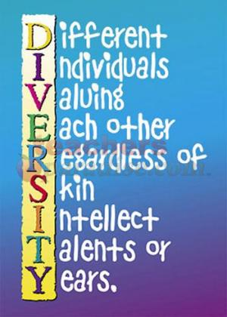

We would like you to complete a piece of work which is based on one of the key themes within Health and Social Care units; Equality, Diversity and Rights in Health and Social Care.
The Equality, Diversity and Rights unit addresses a number of important themes which are relevant to health, social care and child care practice today. Many individuals who use health, social care or child care environments can be vulnerable and dependent on others; this means that practitioners’ attitudes, values and prejudices can significantly affect the quality of care for individuals who require care or support experience.
You are advised to use the headings below to structure your work, and the work itself must be submitted to your Health and Social Care teacher during your first lesson.
Task 1: Rights
Select one of the rights identified below and explain how such rights could be neglected or abused within a health, social care or child care environment. What could the potential consequences be for those whose rights have not been respected?
- Choice
- Confidentiality
- Protection from harm
- Equality and fairness
- Consultation
- Right to Life

Task 2: Laws which support rights.
Select one of the pieces of legislation identified below and explain how this law supports the rights of the individual;
- The Care Act 2014
- The Equality Act 2010
- The Children Act 2004

Task 3: Health, Social Care and Early Years organisations. There are many organisations which seek to support the rights of those who have different health, social care or educational needs. Select one of the organisations listed below and explain what the organisations do to support the individuals with which they work;
- SEAP
- Empower Me
- MIND
- Age UK
- The Samaritans
- Headway

Task 4: Research
Find (and attach to your work) an article which concerns issues of equality, rights and/ or diversity within health, social care or early year’s education. Summarise what the article about? What are the key issues? What are your views on the issues raised?

