WQE is one of the largest sixth form providers in England; a large twin-site college, centrally located in the city of Leicester. The College’s most recent Ofsted inspection was in March 2022 where we received a Grade 2 (Good) for Overall Effectiveness.
WQE aims to develop young professionals to be qualified to Level 3 and ready to progress to Level 4. We recognise that our students join us from a diverse range of backgrounds and are responsive to individual needs to support all students in a successful transition from school to Post-16 education.
We actively encourage you start engaging with us at this early opportunity by completing the induction task below and submitting it to your class teacher during your first lessons in September
The task outlined below will give you an idea of what this Level 2 course involves.

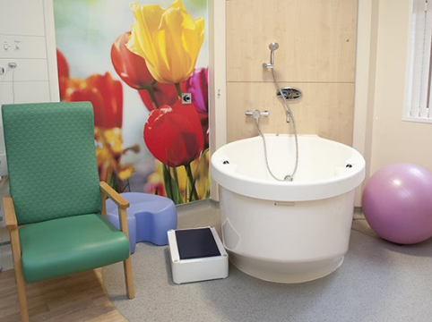
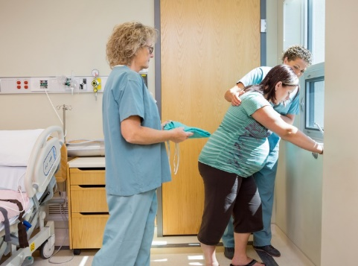
Level 2 Health & Social Care
This will need to be handed in during your first Health & Social Care Lesson in college. Write or type these tasks and include your name.

Unit 1 Communication in Health and Social Care.
Communication is a vital skill in care of individuals within Health, Social and Child care. Communication can be verbal and non-verbal (body language) – up to 70% of what we communicate is done non verbally! People you support in a health care setting may be scared, upset or in pain and this will affect how they understand what you are saying. Skilled communication requires you to use many different ways of giving information.
TASK 1. Complete the mind map below with as many different communication skills you can think of. (Tip – think about how you use words, tone of voice & body)

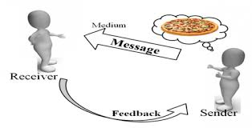

Read the following case study from the Leicester Royal Infirmary Maternity Unit.

Anaar Jahan and her husband Behzad arrived in the UK from Afghanistan in 2017. Anaar is expecting her first baby and has come into the Leicester Royal Infirmary maternity unit after having labour pains for 7 hours at home. She is frightened and in pain. They both speak some English but Dari is their first language. Anaar was a nurse in Afghanistan and Behzad was a business man.
When they arrive at the Labour ward a midwife starts to ask questions about Anaar’s health and wants to examine her. She talks very quickly and is a bit of a rush as she has a difficult labour to supervise down the corridor. Anaar is in the middle of a contraction and cannot speak properly. Behzad tries to use his phone to translate what the Midwife is saying.

Key words – BARRIER – a difficulty or problem. CONTRACTION – a spasm of womb muscles to help the baby out.
TASK 2
Describe 2 different barriers that could make communication difficult between the midwife and her client in the case study above.
- ……………………………………………………………………………………………………………………………………………………………………………………………………………………………………………………………………………………………………………………………………………………………………………………………………………………………………………………………………………………………………………………………………………………………………………………………………………………………………………………………………………………………………………………………………………………………………………………………………………………………………………………………………………………………………………………………………………………………………………………………………………………………………………………………………………………………………………………………………………………………………………………………………………………………………………………………………………………………………………………………………………………………………………………………………………………………………………………………………………………………………………………………………………………………………………………………………………………………………………………………………………………………………………………………………………………………………………………………………………………………………………………………………………………

- ………………………………………………………………………………………………………………………………………………………………………………………………………………………………………………………………………………………………………………………………………………………………………………………………………………………………………………………………………………………………………………………………………………………………………………………………………………………………………………………………………………………………………………………………………………………………………………………………………………………………………………………………………………………………………………………………………………………………………………………………………………………………………………………………………………………………………………………………………………………………………………………………………………………………………………………………………………………………………………………………………………………………………………………………………………………………………………………………………………………………………………………………………………………………………………………………………………………………………………………………………………………………………………………………………………………………………………………………………………………………………………………………………………………………………………………………………………………………………………………………

TASK 3
Have a 10-minute conversation with someone you know. Evaluate your own communication skills in the table below.
Skills | Rating |  |  |  |  | Comments – what made you give that rating?
Non-verbal communication
Eye contact | 1 | 2 | 3 | 4 | 5
Facial expression | 1 | 2 | 3 | 4 | 5
Tone of voice | 1 | 2 | 3 | 4 | 5
Gestures | 1 | 2 | 3 | 4 | 5
Posture | 1 | 2 | 3 | 4 | 5
Touch | 1 | 2 | 3 | 4 | 5
Proximity (nearness) | 1 | 2 | 3 | 4 | 5
Verbal communication
Encouragement & prompts | 1 | 2 | 3 | 4 | 5
Questioning | 1 | 2 | 3 | 4 | 5
Use of appropriate language | 1 | 2 | 3 | 4 | 5
Active careful listening  Not interrupting/paraphrasing what you have heard. | 1 | 2 | 3 | 4 | 5

