Hand in on your first Graphics lesson.
Typography is relevant to many forms of Art/Graphic Design, including posters, tickets, quotes, book covers and much more… It can be found in all forms, from hand calligraphy, to portraits made out of text and logos.

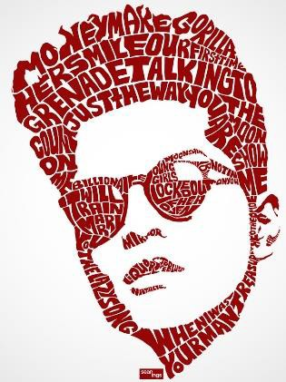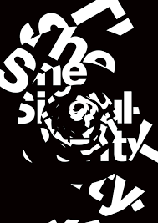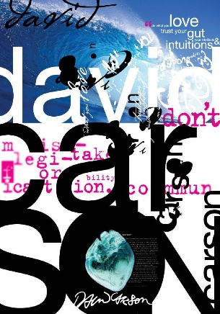
Look at two different typography artists/designers and produce two research pages. These usually include a title, images of the artist’s work, a bit of analysis (your opinion, pros and cons) and a copy/recreation. You then need to come up with your own Typography design poster. This could be based on a song lyric, a political poster, a famous quote, a portrait design, even a film poster. This piece can be made on the computer or by hand and can be made out of any material you choose.

Objectives:
- To explore a range of existing designers work.
- To create small copies of existing designers work using either: digital, painting, drawing,
or calligraphy
- To create a piece of Graphic work that reflects your understanding of typography using famous quote, song lyrics, and so on

Outcomes:

Your work should include evidence of all of the objectives above. You can choose how to present your findings; it could be presented as a mini sketchbook, or on separate sheets, by hand or digital. The poster submitted should be no bigger than A3. You should not write more than 200 words about each Designer.

Resources:
You can find information on Typography artists/designers using theses links:

5 typography artists: http://inkbotdesign.com/5-typography-artists-worth-following/
10 typography artists: http://abduzeedo.com/10-amazing-typography-artists

Questions? Contact: Melanie.harper@wqe.ac.uk
Kit List for Graphics Students at WQE

Essential: For the beginning of term.
An open mind, a creative approach, commitment
Access to a laptop with WIFI
Adobe Illustrator and Photoshop
A3 hardback sketchbook (from college Wisepay)
Printer credit (from college Wisepay)
USB drive
A range of pencils including from HB to 4B
Fine liners and broader black felt tip pens
A 30 cm Metal ruler
Scissors
Pritt Stick
Eraser
Pencil sharpener
Masking tape/sellotape

Desirable:
A budget student range of paintbrushes
Double sided tape
colour pencils
watercolour paints
Compass
Smartphone with apps: Snapseed/Layout/Hipstamatic/Pinterest/instagram

Research and Reading Publications:
The Graphics library in the studio
WQE College library Art and Design section
Eye Magazine (available to read in the studio and on line)
Graphis magazine (available to read in the studio and on line)

On line:
WQE on line resources for Graphics Yr1 and 2
Pinterest: Melanie Harper@WQE

Also use insta to follow designers too
Instagram: Dailyposter
Graphic designers on Youtube/Behance

