You need to complete the two induction tasks below to the best of your ability and hand in a paper copy to your teacher in your first face to face lesson of geography.
We are checking to see where you need support in extended writing, maths skills and geographical skills
Task one: Extended writing
North West Bicester - A sustainable urban environment?
North West Bicester is Britain’s first eco town; it is a development, which has been designed to be good for the environment and the economy.
Most important of all, it is designed to be a great place to live.
The idea is to build sustainable neighbourhoods where:
- Families can afford to live – 25 % affordable homes
- Jobs are created for local people
- Children can play outdoors safely
- Wildlife can thrive - 40% green space, all garages will have meadow turf roofs, existing hedgerows kept, network of sustainable wildlife corridors and ponds.
- And there’s a strong community spirit

One neighbourhood in North West Bicester is Elmsbrook, pictured below, and includes 393 new eco homes and many new jobs

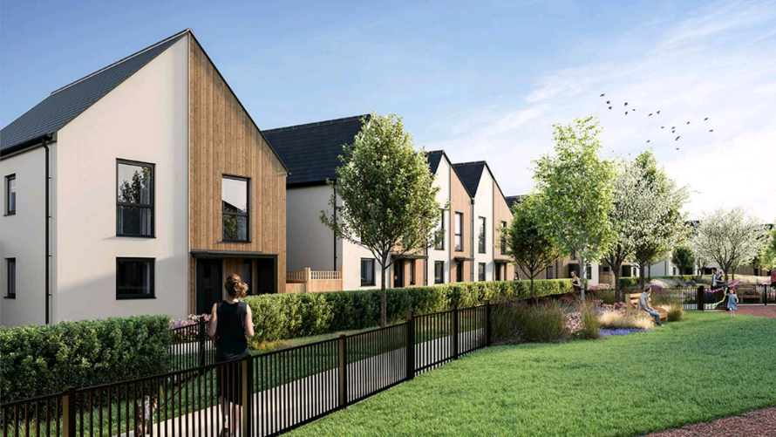

Your tasks:
- Find out more about MW Bicester by exploring this website:
NW Bicester – One Planet Living® Leader – Bioregional
- Use all of the above and the ‘Government sustainability guidelines’ listed below to write a maximum of two sides of A4 to answer this question:

To what extent do the plans for NW Bicester illustrate the dimensions of economic, social and environmental sustainability?
[9 marks]

Government’s sustainability guidelines for eco towns

The Government’s sustainability guidelines state that eco towns must meet the following criteria to be classed as economically, socially and environmentally sustainable:

- Zero carbon
Over a year the net carbon dioxide emissions from all energy use within the buildings in the eco-town development as a whole are zero or below. The definition of zero carbon applies to the whole development rather than individual buildings.

- Climate change adaptation
Eco-towns should be sustainable communities that are resilient to the climate change that is now accepted as inevitable. They should be planned to minimise future vulnerability in a changing climate.

- Homes
Must meet lifetime homes standard and space standards, have energy monitoring systems, provide for at least 30% affordable housing, demonstrate high energy efficiency in the fabric of the building.

- Transport
Travel in eco-towns should be designed to give priority to options such as walking, cycling and public transport.

- Green infrastructure
40% of the eco-town total area should be allocated to green space, of which at least half should be public.

- Biodiversity
Eco-towns should show a net gain in biodiversity.

- Water
Eco-towns should be efficient in terms of water efficiency

Useful information:
- Time to complete this task: You should spend around 2 hours on this task including research.
- Definitions of the dimensions of sustainability

Economic sustainability - means that the economic needs and limitations of people are considered (jobs and incomes)
Social sustainability – means that people’s quality of life is considered (individuals and communities enjoy living here)
Environmental sustainability – means that the natural environment is considered (air, water and wildlife/biodiversity)

The mark scheme below will help you to include the right ideas and understand the question

- Mark scheme

Your induction task will be marked out of 9 marks using the following:
Level 1
1-3 marks
- Lists/describes the characteristics of NW Bicester. Some linkage to sustainability at upper end.
- TWE (‘to what extent’) is not evaluated at all.
Level 2
4-6 marks
- Begins to explain how the characteristics of NW Bicester link to aspects of sustainability
- Begins to consider TWE – probably in the final section. Refers to some government sustainability guidelines – but linkage to NW Bicester is weak.
Level 3
7-9 marks
- Explains clearly how characteristics of NW Bicester link to all 3 dimensions of sustainability. May consider links between different aspects of sustainability.
- Considers TWE throughout the answer. Refers directly to most of the 7 government sustainability guidelines and clearly links to situation in NW Bicester. May evaluate some of the ways in which NW Bicester is not sustainable.

Task two
- Write your answer to this question on this sheet on the lines provided

- Complete Figure 1 by adding the data shown below

- Describe the patterns in the data - for example where is the graph high or low. Use evidence from the graph to support your description

- Can you identify any links between the percentage of water in the reservoir and the time of year
[6 marks]

Month | Percentage of reservoir capacity
October 1995 | 48
October 2012 | 95

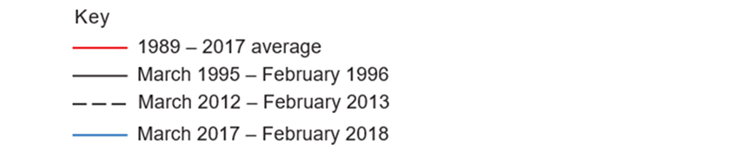

______________________________________________________________________________
______________________________________________________________________________
______________________________________________________________________________
______________________________________________________________________________
______________________________________________________________________________
______________________________________________________________________________
______________________________________________________________________________
______________________________________________________________________________
______________________________________________________________________________
______________________________________________________________________________
______________________________________________________________________________
______________________________________________________________________________
______________________________________________________________________________
______________________________________________________________________________
______________________________________________________________________________
______________________________________________________________________________
______________________________________________________________________________
______________________________________________________________________________
______________________________________________________________________________
______________________________________________________________________________
______________________________________________________________________________
______________________________________________________________________________
______________________________________________________________________________
______________________________________________________________________________
______________________________________________________________________________
Useful information:
- Time to complete this task: You should spend 30 minutes on this task
- The mark scheme below will help you to include the right ideas and understand the question
Level 1
1-3 marks
- The graph is plotted with a degree of care and accuracy
- Trend(s) are identified and supported with some evidence
- A link between capacity and time has been identified tentatively
Level 2
4-6 marks
- The graph is plotted with care and accuracy
- Trends are identified and supported with relevant evidence
- Data manipulation is evident – for example this reservoir has 3 times as much……
- Possible anomalies have been considered
- A link(s) between capacity and time has been fully explored

