Drawing from Observation
Welcome

Here’s your introductory task to be completed ready for our first lesson.

Introduction
With this task you are being asked to write about one image, copy it and then produce your own drawing in response to it. The task has been designed to enable you to show your written skills and to demonstrate your strength at drawing from secondary and primary sources.

Stages
- I would like you to select one of the observation drawings on the pages below (you can choose something else, but not a cartoon as it must be a real object or subject).
- Carefully copy it on A4 paper accurately using a 2B, 3B or 4B pencil (fill the page).
- Then I would like you to write about the drawing that you have copied (i.e. consider your accuracy at drawing, use of tone and mark making etc.).
- Finally, complete one A4 size pencil study based on the same theme, but this time work from a real object or from a photograph that you have taken yourself.

You should spend about four hours on this task. We will glue this work into your sketchbook later.

Good luck! Jacqueline.
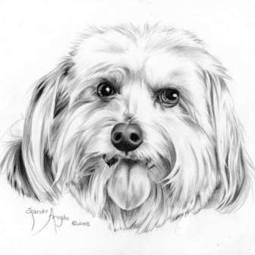
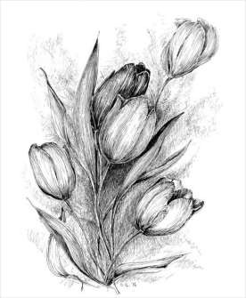

Please turn over…….

