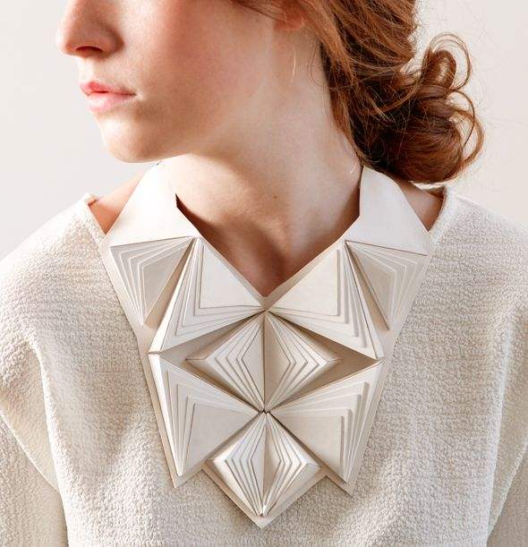
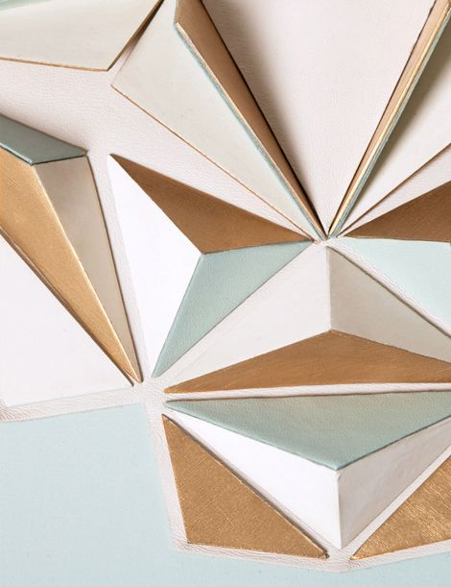
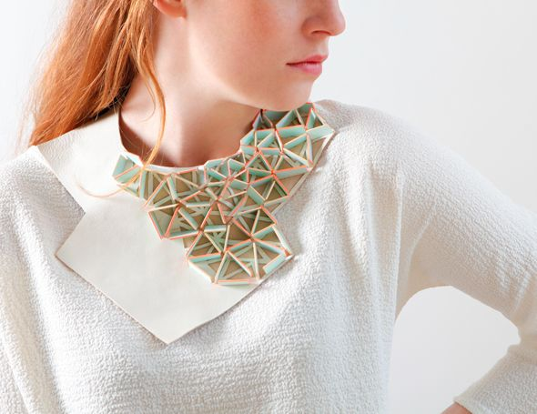
Maud Rondot Bijoux.
Research into her designs, paying particular attention to her use of the repetitive origami shapes. (You will find information on the internet, but also Pinterest for quality images – if you do not have a Pinterest account – it is free & easy to start one & will yield a mass of high quality images for your research development).

Make small observed samples in a small A5 sketchbook & then develop the technique/idea to reflect your own slant (specifically you could draw/illustrate or stitch into the surface of your paper/card/fabric prior to manipulation.
Produce a min of x 4 pages in your A5 Sketchbook.
Note that the design to the right is actually sitting on top of a shaped collar.
Jane Bowler.
Research into the designs of Jane Bowler, observe the use of repetitive shapes that are simply connected together to form almost a chain-mail quality – one that is able to fold around the contours of the human body.
Often the repetitive shape is a triangle.

Experiment with cutting a series of triangles out of thin card & connecting them in a creative way – you could stitch them together or use metal jump rings (you can buy these on Amazon) - note the movement this creates.
You could also stitch into the triangles.

Produce a minimum of X 4 double page spreads on her work, with samples & add fashion illustrations to really showcase your ideas.

Once you have collected your research on these Designers, you will need to create a small mini outcome of a collar/neckpiece idea.
You could use a basic collar template & then literally build your designs directly on top of the template – explore & expand your ideas into a suitable mini outcome for your return.
All work must be submitted in your first Textiles lesson.

Observe all of the different shapes that Jane Bowler explores & try making samples of your own, so that you can feel how each one acts & the limitations of certain shapes compared to others – make a note of your findings & ensure that the examiner is able to see your documentation – label it carefully.

Teacher: Deborah Lovegrove
Designer research–Origami in Fashion

Kit List

YOU MUST HAVE ACCESS TO A SEWING MACHINE TO COMPLETE THIS COURSE. (The best machines to buy are Bernina’s – you can pick them up off eBay).
The owner of ‘Material Magic’, Market Place, Leicester (Sanjay Bhalla) usually gives 10% discount of all fabrics & threads purchased from him (you will need to say that you are studying Textiles with Deb Lovegrove).
You will be using these items during your first week at college and all students enrolling on this course are expected to provide their own sewing kit. This is a list of essential items, you may already have some items that can be used or added too to complete your kit.
Essential items
- 1 plastic work box to store all your items in.
- A box of dressmakers pins. (Available from Button Boutique – Malcolm Arcade).
- X 1 metre of medium weight Calico. (Available from Material magic).
- X 2 metres of white net. (Available from Material magic).
- X 1 metre of black net. (Available from Material magic).
- X 1 metre of clear PVC. (Available from Material magic).
- 1 large pair of good quality fabric scissors. (Available from Button Boutique – Malcolm Arcade).
- 1 small pair of good quality fabric scissors (suitable for cut work – so very sharp pointed – (Available from Button Boutique – Malcolm Arcade) Or you can also use small scientific dissecting scissors – available from Amazon).
- 1 pack of hand sewing needles. (Available from Button Boutique – Malcolm Arcade).
- 1 pack of beading needles. (Available from Button Boutique – Malcolm Arcade).
- A needle threader. (Available from Button Boutique – Malcolm Arcade).
- 2 reels of good quality white sewing thread (for machine work). (Available from Material magic).
- 3 reels of good quality black sewing thread (for machine work). (Available from Material magic).
- A 6’’ embroidery ring. (Available from Button Boutique – Malcolm Arcade).

Non sewing items
- An A3 11” SQ hardback Journal available to buy from college (this will be ordered once you have enrolled).
- Uni Posca PC-1M Paint Pen Art Marker Pens – pack of 12 assorted colours –
https://www.amazon.co.uk/Uni-Posca-PC-1M-Paint-Marker/dp/B0747T85ZW/ref=sr_1_21?keywords=posca+acrylic+marker+pens&qid=1566376563&s=gateway&sr=8-21
- 2B pencil
- A permanent fine liner for fashion illustration – extra fine nib.
- Double sided tape.
- A Pen drive to keep your work on.
- X 10 A4 sheets of clear acetate – (suitable for OHP projectors - this is cheaper - you can buy this from Amazon – in boxes of 100 sheets – you will use lots of it over the year).
(This link will lead you to a box of 60 sheets for £6.49)
https://www.amazon.co.uk/A4-Overhead-Projector-Film-OHP/dp/B01LZBEUAL/ref=sr_1_5?ie=UTF8&qid=1536515503&sr=8-5&keywords=ohp+transparency+sheets

PLEASE ENSURE YOU LABEL ALL OF YOUR KIT & BRING IT TO YOUR FIRST LESSON.

