Name……………………………………………………………………………………….

Task One

Name as many professional theatres that you can discover in a 50 mile radius around and including Leicester City (Complete on a separate sheet.) There will be a prize for the most found!

Task Two

The following are some Drama techniques and Theatre styles, explain in your own words what they mean and how you could use them.

Drama Term | The Meaning | How would you use these in your Drama work?
Naturalistic

Stylised Performance

Physical Theatre

Role Play

Task Three
Label this picture of the Olivier Theatre interior as accurately as you can

Include the following features

Main Stage/ Auditorium / Balcony / Stalls / Lighting Rig / Wings / Flats / Stage Furniture

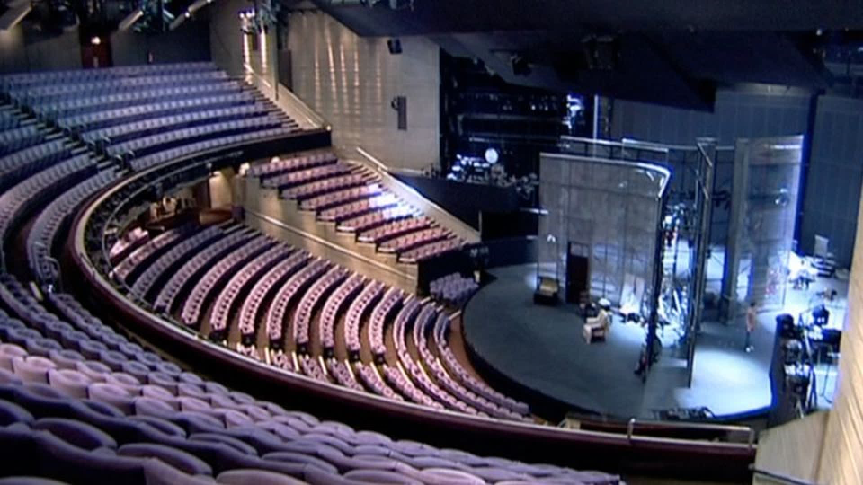

Task Four

Choose a play that you have seen recently, if you haven’t seen a live play-choose a film or TV Drama that you have enjoyed and complete the questions All work must be handwritten neatly

What play / musical / film / Drama did you see? Where did you see it and what made you choose this one particularly?
______________________________________________________________________________________________________________________________________________________________________________________________________________________________________________________________________________________________________________________________________________________________________________________________________________________________________________________________________________________________________________________________

Choose one moment that you really enjoyed, what made it so memorable? Give an example.

______________________________________________________________________________________________________________________________________________________________________________________________________________________________________________________________________________________________________________________________________________________________________________________________________________________________________________________________________________________________________________________________

Task Five

Discuss one actor (either male or female), what did they bring to the role? Explain why you found them so effective; give an example of a scene where they were impressive and try to explain why.

______________________________________________________________________________________________________________________________________________________________________________________________________________________________________________________________________________________________________________________________________________________________________________________________________________________________________________________________________________________________________________________________
______________________________________________________________________________________________________________________________________________________________________________________________________________________________________________________________________________________________________________________________________________________________________________________________________________________________________________________________________________________________________________________________
______________________________________________________________________________________________________________________________________________________________________________________________________________________________________________________________________________________________________________________________________________________________________________________________________________________________________________________________________________________________________________________________
______________________________________________________________________________________________________________________________________________________________________________________________________________________________________________________________________________________________________________________________________________________________________________________________________________________________________________________________________________________________________________________________
______________________________________________________________________________________________________________________________________________________________________________________________________________________________________________________________________________________________________________________________________________________________________________________________________________________________________________________________________________________________________________________________
_______________________________________________________________________________________________________________________________________________________________________________________________________________________________________________________________

