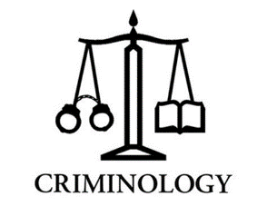
WJEC National Diploma in Criminology
Enrolment Task
As part of the course, it is important you know about different types of crime and have researched some examples. Using the internet and/or books we would like you to find a specific example of each of the following types of crime. You could look at news articles, websites, documentaries or textbooks.
You will need to bring your completed table to your first Criminology lessons where you need to be ready to discuss the cases with other students in the class. Your teacher will also want to see it.

Type of Crime | Definition | Where and when did the crime take place? | Who was involved? | What happened? | What were the outcomes? Was anyone prosecuted? What were the effects on the victim?
White Collar Crime | These are generally non-violent crimes usually committed in commercial situations for financial gain. Examples could include computer and internet fraud, credit card fraud and tax evasion.
Moral Crimes | Moral crimes are crimes against the normal standard of morality within society. Examples include prostitution, vagrancy, under-age drinking, assisted suicide, illegal gambling and illegal drug use.
State Crimes | State crimes are activities perpetuated by, or by order of, state agencies, such as governments that commit crimes in order to further their policies. For example, genocide, war crimes, torture and imprisonment without trial.
Technological Crimes | Also known as cybercrime, technological crime is when the offence is committed using the internet or other technologies. Examples include internet enabled fraud, downloading illegal materials such as songs and images and the use of social media to promote hate crimes.
Honour Crimes | Honour crimes are punishments on people for acts deemed to have brought shame on their families. Examples include acid attacks, abductions, mutilations, beatings and murder.
Hate Crimes | Crimes where the perpetrator is perceived to be motivated by hatred of the victim because of the victim’s race, religion, sexual orientation or transgender identity.
Domestic Abuse | Domestic abuse is any act targeted to be abuse against a partner/family member that happens within the home, often in secret. Domestic abuse can include physical violence such as assault, torture, murder and verbal abuse. It can also include emotional abuse to the victim, such as name calling or controlling behaviour.

