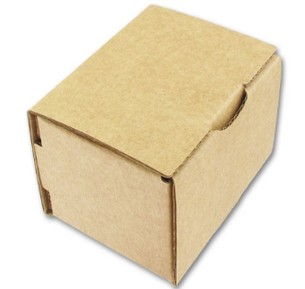
The Box

You have been given this cardboard box.
How are you going to turn it into a profitable product?

Your task is to turn this box into a product that will make a profit. You can do anything to it: redesign the packaging, put things inside it and so on. The box itself costs 8p.
You must:
- Write a brief plan (a minimum of 1 page) including:
- What the business will do or sell (Product)?
- The benefits and features of your offering?
- Where you intend to sell it (Place)?
- How you intend to get it to your customers?
- Who your customers will be?
- How your business will be different from its competitors (its USP)?
- How you plan to target potential customers (Promotion)?
- How you will price your product/service (Price)?
- The profit you think you might make on each offering/item?

Get your thinking caps on and good luck!
Some ideas that you cannot steal!
