A LEVEL BIOLOGY
INDUCTION TASKS

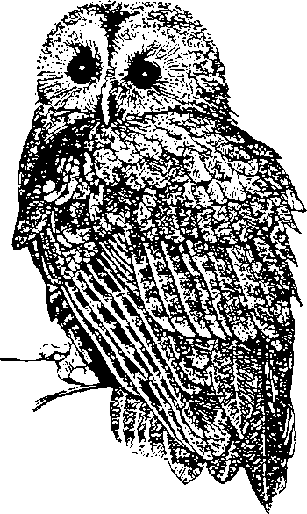

You need to complete these tasks and bring them to your first biology lesson. You can either print out the document and fill it in, or complete your answers on file paper

NAME ___________________ DATE _______

You should be familiar with the structure and function of some organelles from GCSE. In A-level Biology, we will study eukaryotic cells in more detail.

From AQA GCSE Biology specification:

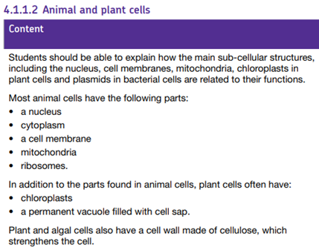

From AQA A-level Biology specification:

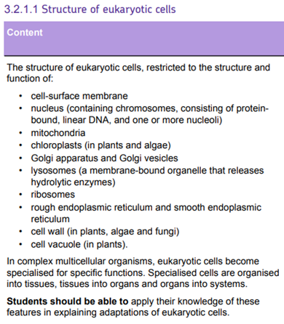

Your Two Induction Tasks
***Remember to bring this to your first Biology lesson***

Task 1

Draw diagrams of plant and animal cells and label each of them using all the structures that are listed in the A-level specification above.

Task 2

Use this table, or draw your own, to briefly describe the structure and function of each organelle from the A-level specification

Organelle | Structure | Function
Cell surface membrane | It consists mainly of a phospholipid bilayer containing proteins. It also has cholesterol, glycoproteins and glycolipids | Partially permeable to control entry and exit of substances. Glycoproteins and glycolipids are involved in cell recognition and communication and cholesterol controls the stability of the membrane
Nucleus

Mitochondria

Chloroplast (plant)

Golgi apparatus

Golgi vesicles

Lysosomes

Ribosomes

Rough Endoplasmic Reticulum

Smooth Endoplasmic Reticulum

Cell Wall

Cell Vacuole

