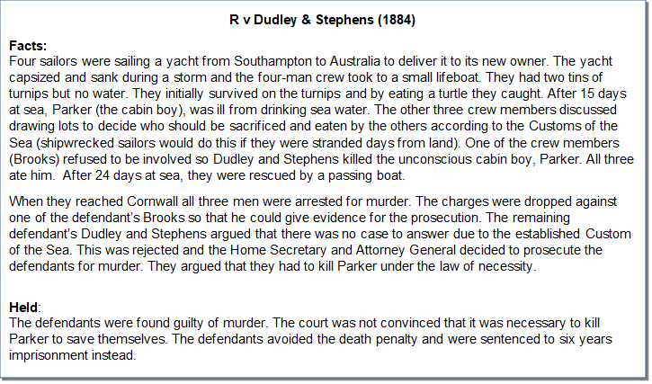

Task

- Do you think this is a criminal case or a civil case?

- Which phrases and / or words in the story helped you decide your answer to question one?

- What defence did the defendants raise?

- What was the verdict, i.e. what was the court’s decision?

- As a member of the jury in this case would you have found them guilty or not guilty? Give reasons for your answer.

- Using the internet or other resources find out what happened in the case Re A (2000) which is another key case on necessity.

