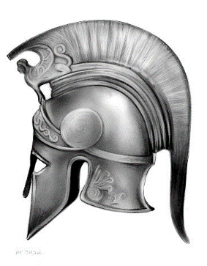

Welcome To A level
Ancient History

Please complete these tasks in time for your first Ancient History lesson. Your answers to Task A, B, C, D and G should be hand-written on a separate sheet of lined paper. Task E and F can be done by filling in the grids.
Task A

In your own words, describe what this ancient sculpture represents
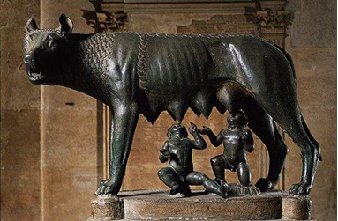

Task B

Define the following ancient terms:

- FORUM
- AMPHITHEATRE
- CONSUL
- SENATOR
- DELIAN LEAGUE
- PELOPONNESIAN LEAGUE
- AGOGE
- HELOTS
- SPARTIATE
- KRYPTEIA
Task C
Athena was one of Greece’s most important goddesses. What can you
find out about her and her temple, the Parthenon?

Task D

This is a statue of the Spartan king Leonidas. What can you find out about him?

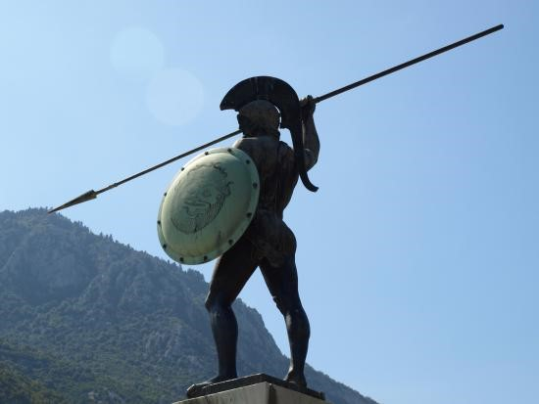

Task E

Put these historical events in chronological order, earliest first:

EVENT | DATE? | EARLIEST?
The Battle of Actium
The death of Alexander the Great
The Battle of Plataea
The death of Julius Caesar
The first Olympic Games | 776BC | 1st
The Roman conquest of Britain
The Battle of Marathon
The traditional date for the founding of Rome
The start of the Peloponnesian War

Task F

Calculate the following dates, counting backwards or forwards using BC or AD:

10 years before 8AD=
10 years before 2BC =
17 years after 12BC =
200 years before 50AD =
600 years after 150 BC =
What is 50 years after 110AD? =
What is 220 years before 110AD?

Task G Explain why you have chosen to study Ancient History at A Level.

