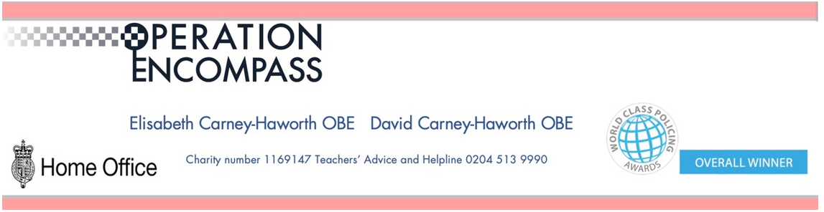

Building upon the national success of Operation Encompass (Police in all 43 forces in England and Wales sharing information with schools about children experiencing domestic abuse) Leicestershire police are expanding the information that they are sharing confidentially with the safeguarding leads in Leicestershire schools.

From the 19th of September 2022 they have started a phased rollout across the Police Force, sharing with us incidents that they have attended where they feel there has been an impact upon a child’s physical, emotional or mental well-being.

We are thrilled the force has made this decision as this confidential information will help us to support and care for the children in our care even more effectively.

More information about Operation Encompass including their statement can be found on their website www.operationencompass.org

As part of the Operation Encompass Information Sharing Platform our Police Force will also share with the Designated Safeguarding Lead information about police attended incidents where they feel that there has been a tangible impact upon a child is physical, emotional or mental well-being.

This information is shared so that our school can better understand children’s living experience and can support, nurture and care for them more effectively.

Our Designated Safeguarding Lead has attended a briefing about this information sharing and has disseminated information to the safeguarding governor and to all members of staff.

