Name:…………………………………………………………………………………..
Teacher:……………………………………………………………………………….

In order to gain an understanding of the types of things we will cover in class, complete the following tasks, ready for your first lesson in Psychology.
In every topic you learn, we cover these main areas, key concepts, explanations (theories) and studies.
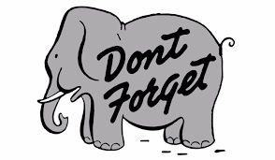
Task 1 – Key concepts
In Psychology you will have to learn the key concepts for all the topics covered
on the specification. To give you an insight into this, find out about types of
forgetting, this link may help; https://www.simplypsychology.org/forgetting.html

Complete the table below:
Types of forgetting | Definition | Can you give a real life example?
Decay

Displacement | 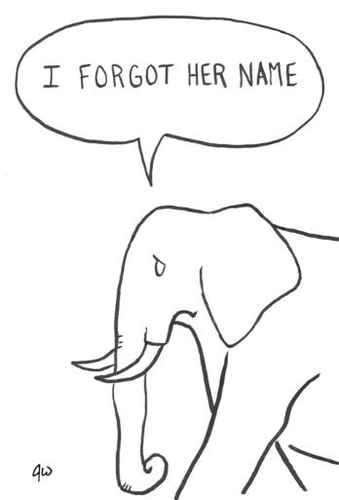
Retrieval failure

Task 2 – Explanations of human behaviour
In psychology you will learn about explanations that have been conducted to help explain human behaviour. Can you complete the fill in the gap activity, using the word bank (and possibly a textbook this link https://www.youtube.com/watch?v=EXquSp2-bfI if you get stuck).

The biological explanation of schizophrenia
The biological explanation of schizophrenia is known as the ………………………………………….. ……………………………. This explanation states that individuals who have an ………………….. active dopamine system, ………………………………………………… levels of dopamine are more likely to develop …………………………………………….
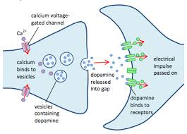
Dopamine is a ……………………………………………………………………… that is associated with our …………………………………, movement and how we …………………………………. things. Schizophrenics …………………….. can change a lot, they can have delusions or …………………………………………………………….., which means they are ………………………….or hearing things that are not there and they can display …………………………….. movement, for example catatonic behaviour.
…………………………. scans have shown that individuals with schizophrenia have dopaminergic …………………………. that fire too easily OR they may have too many dopamine neurotransmitters travelling across the …………………………………………, these then bind to the …………………………….. on the post synaptic neuron, making this neuron excitatory, causing it to fire more.
This causes it to function abnormally and our ……………………………… (thoughts) and ………………………………….. also become …………………………………………………… .
increasing Dopamine hypothesis mood (x2) seeing
over neurotransmitter hallucinations Brain neurons
schizophrenia perceive unusual synapse cognitions
receptors behaviours abnormal

Task 3 - Researching into studies conducted in Psychology
In the topic of Social Influence you will learn about obedience to authority and the power of wearing a uniform on obedience levels. Conduct a literary search in the following study and use this link: https://www.youtube.com/watch?v=KpFP9_bzyQs to help answer the questions that follow:
Literary search - Bickman (1974) study into obedience & the social power of a uniform, experiment 1.
- What was the aim of the study?
……………………………………………………………………………………………………………………………………………………………………………………………………………………………………………………………………………………………………………………………………………………………………………………
- What was Bickman’s hypothesis?
……………………………………………………………………………………………………………………………………………………………………………………………………………………………………………………………………………………………………………………………………………………………………………………………………………………………………………………………………………………………………………………………………………………………………………….
- Bickman conducted a field experiment, what is meant by a field experiment?
………………………………………………………………………………………………………………………………………………………………………………………….
- The independent variable, the variable being manipulated was uniform – what were the uniforms used in the experiment?
…………………………………………………………………………………………………………………………………………………………………………………………………………………………………………………………………………………………………………………………………………………………………………………...

- What were the 3 requests the person wearing the uniform asked a pedestrian to do?
………………………………………………………………………………………………………………………………………………………………………………………………………………………………………………………………………………………………………………………………………………………………………………………………………………………………………………………………………………………………………………………………………………………………………………
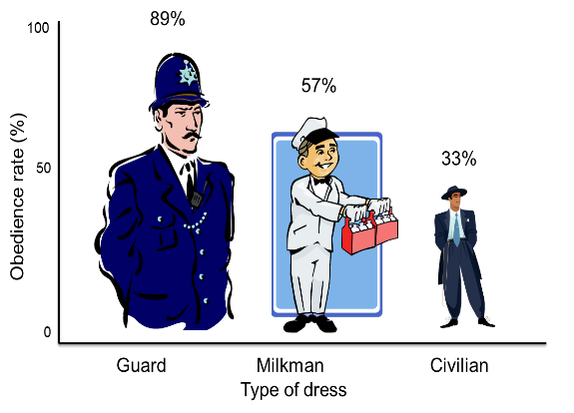
- Which person was obeyed the most?
………………………………………………………………………………………………………………
- Which request was obeyed the least?
………………………………………………………………………………………………………………
- What did Bickman conclude about uniform and obedience rates?
………………………………………………………………………………………………………………………………………………………………………………………………………………………………………………………………………………………………………………………………………………………………………………………………………………………………………………………………………………………………………………………………………………………………………………

