Subject | L3 CTEC Sport
Teacher | Zoe Bailey
Subject Context | The anatomy and physiology of the human body is integral to the study of sport. Understanding how our body operates allows us to begin to understand, control and improve human movement.
Resources required | Laptop (or pen and paper)  Internet (desirable not essential)  www.brianmac.co.uk  www.theeverleaner.com  CTEC Sport text book https://www.hoddereducation.co.uk/subjects/sport-pe/products/level-3/cambridge-technicals-level-3-sport-and-physical-ac
Assignment details | Complete the following 15 questions and activities. There is an extension activity at the end should you wish to complete the assessment questions

Level 3 Cambridge Technical: Sport & Physical Activity
- Label the skeleton
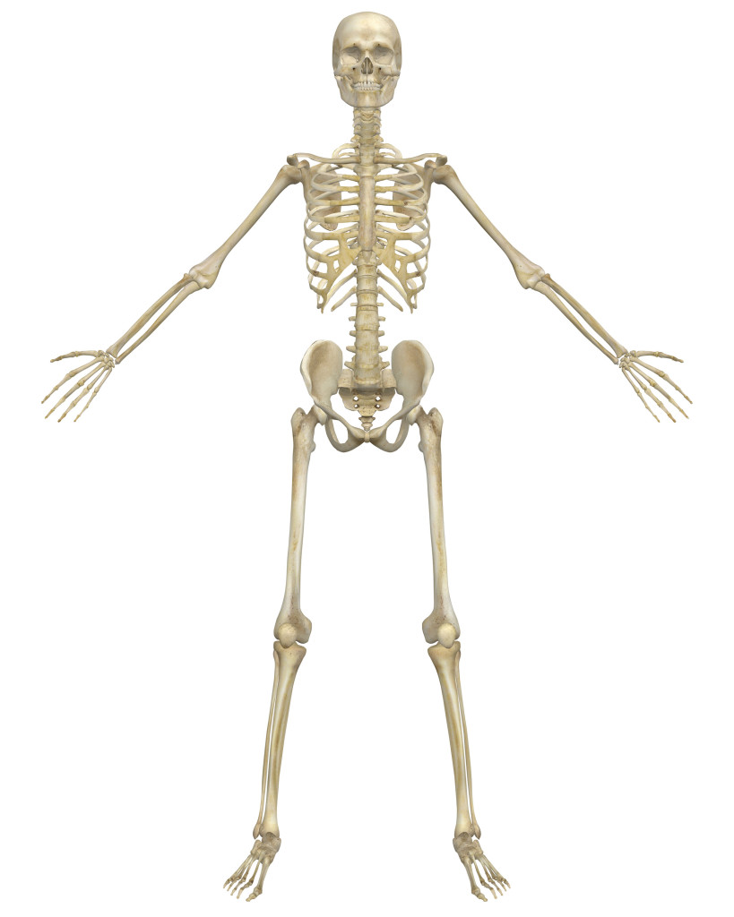

Axial skeleton, i.e.
• cranium
• sternum
• ribs
• vertebral column
o cervical vertebrae
o thoracic vertebrae
o lumbar vertebrae
o sacrum
o coccyx

Appendicular skeleton, i.e.
• scapula
• clavicle
• humerus
- Ulna
- radius
• carpals
• metacarpals
• phalanges
• ilium

• ischium
• pubis
• femur
• patella
• tibia
• fibula
• tarsals
• talus
• metatarsals

The Vertebral Column

Name/label the bones of the vertebral column & add any other relevant detail. Consider the structure and function.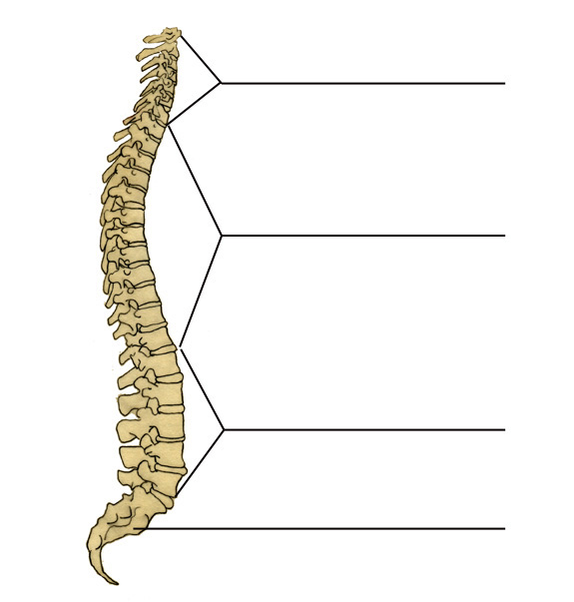
- Name three bones of the appendicular skeleton

- Name three bones of the axial skeleton

- What are the functions of the skeleton?

- Give one function of a long bone and a different function of a flat bone.

- Aside from long and flat bones, name the other three types of bone

- Are the vertebrae: (tick the correct answer
- Fixed joints
- Slightly moveable joints
- Freely moveable joints

- Give the other name for freely moveable joints

- Name the six different types of joint

- Synovial joints contain the following structures. Complete the table below
Structure | Description | Function
articular/hyaline cartilage
synovial membrane
synovial fluid
ligaments
menisci
pads of fat
bursae
joint capsule

- What are the short term effects of exercise/training on the skeleton?

- What are the long term effects of exercise/training on the skeleton?

- Label the muscle diagram below
shoulder – deltoid, latissimus dorsi, pectoralis major, trapezius, teres major
elbow - biceps brachii, triceps brachii
radio-ulnar - pronator teres, supinator muscle
wrist - wrist flexors, wrist extensors
vertebral column - rectus abdominus, erector spinae group, internal and external obliques
hip – iliopsoas, gluteus maximus, gluteus medius, gluteus minimus, adductor longus, adductor brevis, adductor magnus
knee - rectus femoris, vastus medialis, vastus intermedius, vastus lateralis, biceps femoris, semimembranosus, semitendinosus
ankle - tibialis anterior, gastrocnemius, soleus

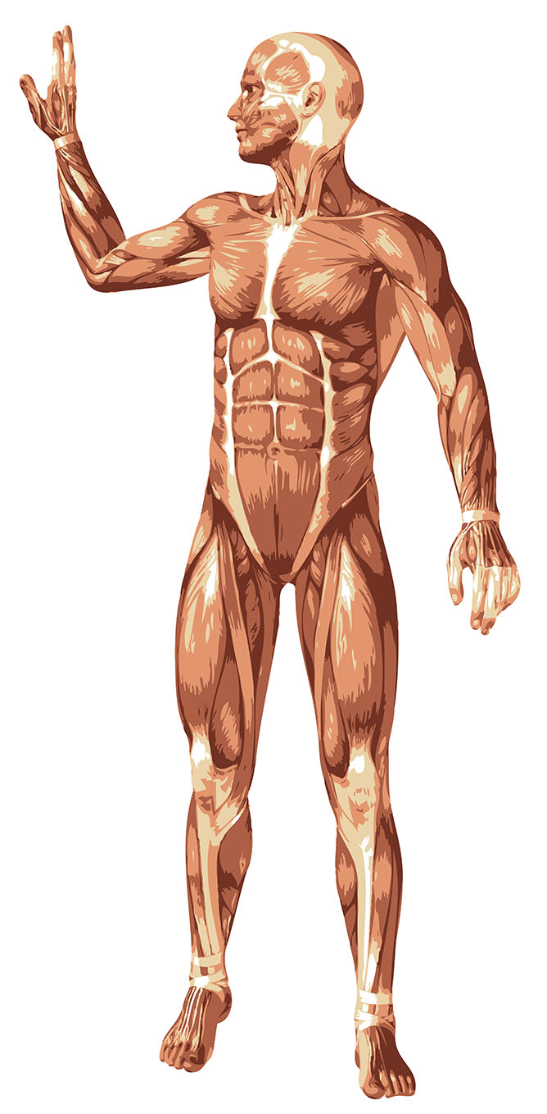

- What is the difference between a ligament and a tendon?

- There are three different muscle fibre types. Identify their structure, function and the type of activity in which they would dominate.

Structure | Function | Type of activity
slow oxidative

fast oxidative

fast glycolytic

- The three Energy Systems – use the table below to research and
 | ATP-PC/Alactic System | Lactic Acid System | Aerobic System
Type of Reaction (Aerobic or Anaerobic)
Chemical or Food fuel
Amount of ATP produced
By-products
Additional Info

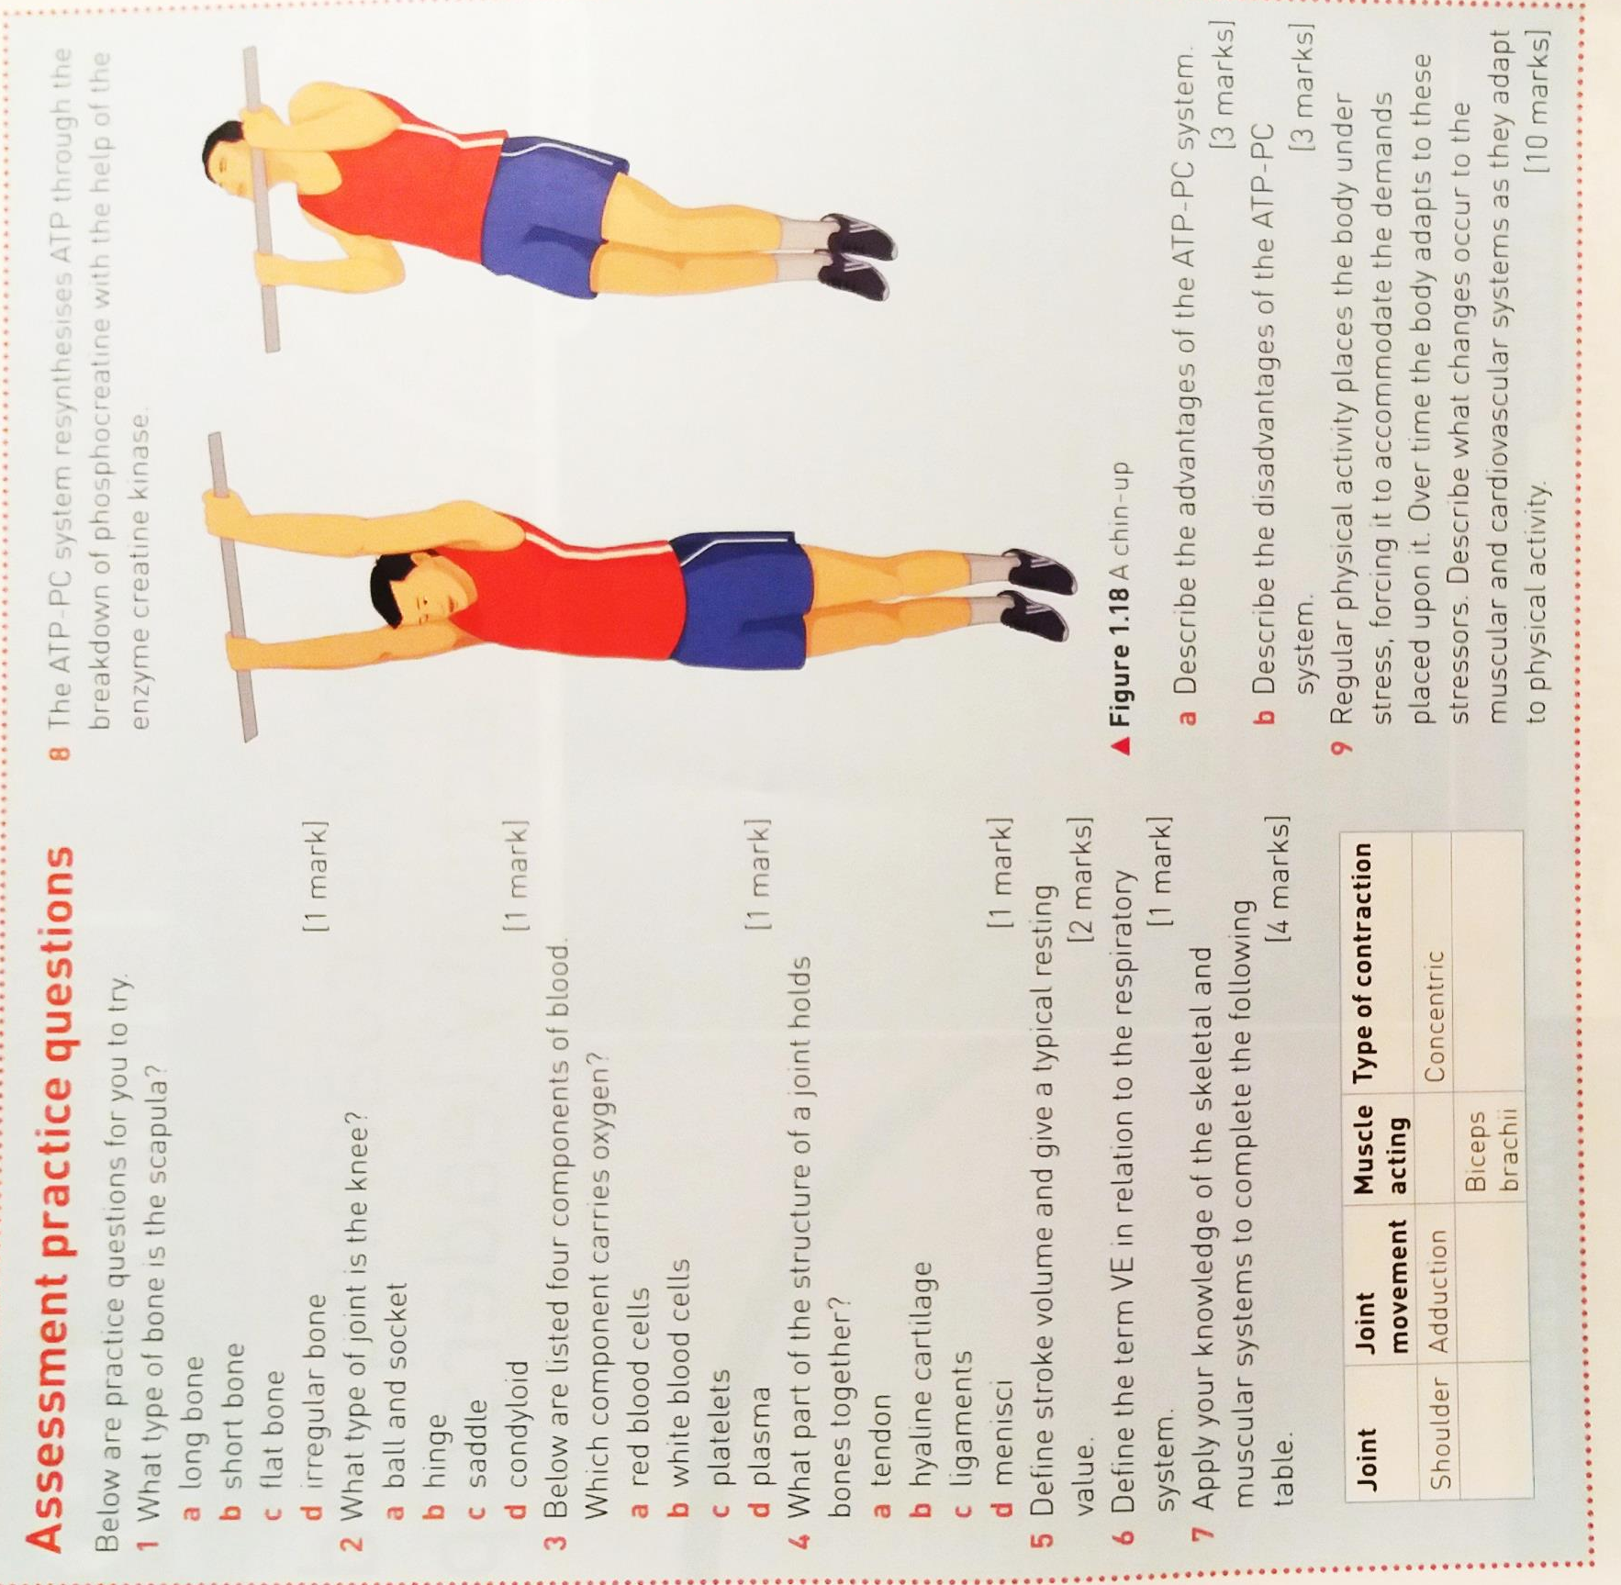
Extension Activity – Assessment practice questions

