Subject | L2 Sport
Teacher | Zoe Bailey
Subject Context | The anatomy and physiology of the human body is integral to the study of sport. Understanding how our body operates allows us to begin to understand, control and improve human movement.
Resources required | Laptop (or pen and paper)  Internet (desirable not essential)  www.brianmac.co.uk  www.theeverleaner.com  https://www.bbc.co.uk/bitesize/guides/zyqd2p3/revision/2
Assignment details | Complete the following 15 questions and activities. There is an extension activity at the end should you wish to complete the assessment questions

Level 2 Cambridge Technical: Sport & Physical Activity
- Label the skeleton
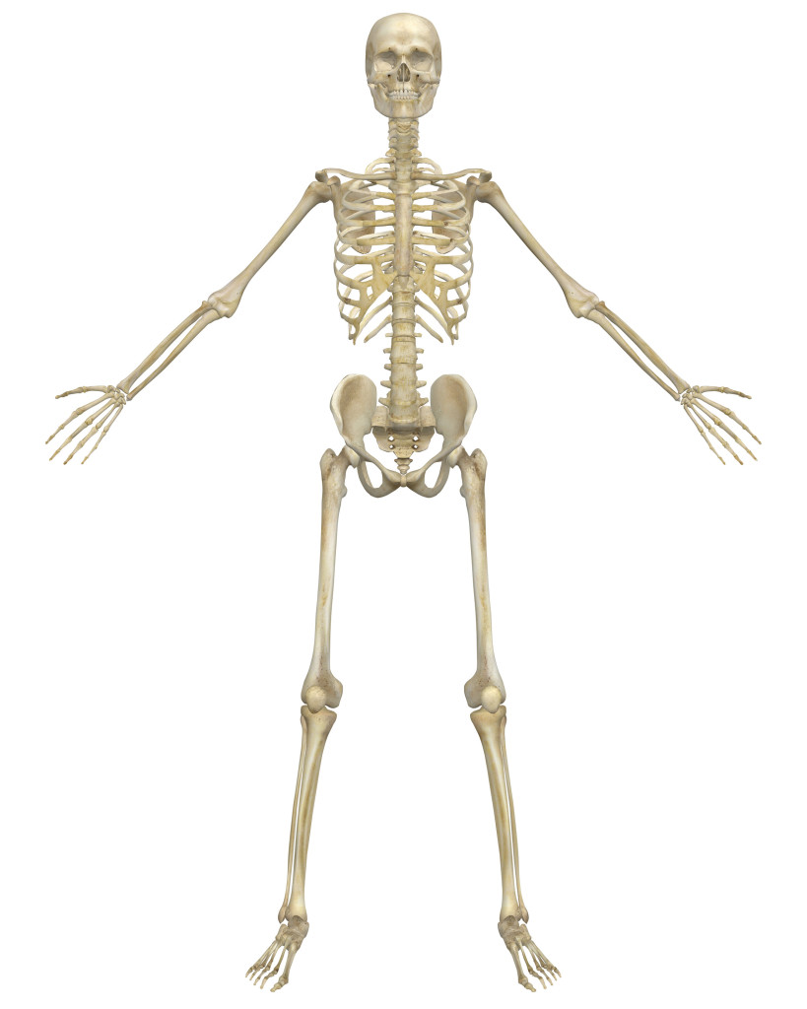

Axial skeleton, i.e.
• cranium
• sternum
• ribs
• vertebral column
o cervical vertebrae
o thoracic vertebrae
o lumbar vertebrae
o sacrum
o coccyx

Appendicular skeleton, i.e.
• scapula
• clavicle
• humerus
- Ulna
- radius
• carpals
• metacarpals
• phalanges
• ilium

• ischium
• pubis
• femur
• patella
• tibia
• fibula
• tarsals
• talus
• metatarsals

The Vertebral Column

Name/label the bones of the vertebral column & add any other relevant detail. Consider the structure and function.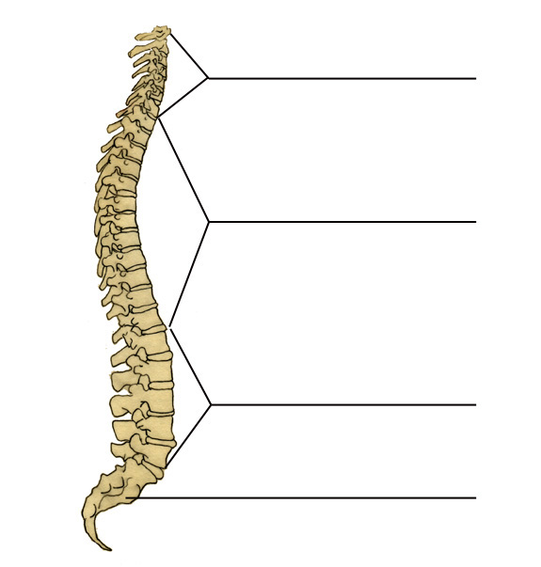

- Name three bones of the appendicular skeleton

- Name three bones of the axial skeleton

- What are the functions of the skeleton?

- Give the other name for freely moveable joints

- Name the six different types of joint

- Label the muscle diagram below
shoulder – deltoid, latissimus dorsi, pectoralis major, trapezius, teres major
elbow - biceps brachii, triceps brachii
radio-ulnar - pronator teres, supinator muscle
wrist - wrist flexors, wrist extensors
vertebral column - rectus abdominus, erector spinae group, internal and external obliques
hip – iliopsoas, gluteus maximus, gluteus medius, gluteus minimus, adductor longus, adductor brevis, adductor magnus
knee - rectus femoris, vastus medialis, vastus intermedius, vastus lateralis, biceps femoris, semimembranosus, semitendinosus
ankle - tibialis anterior, gastrocnemius, soleus

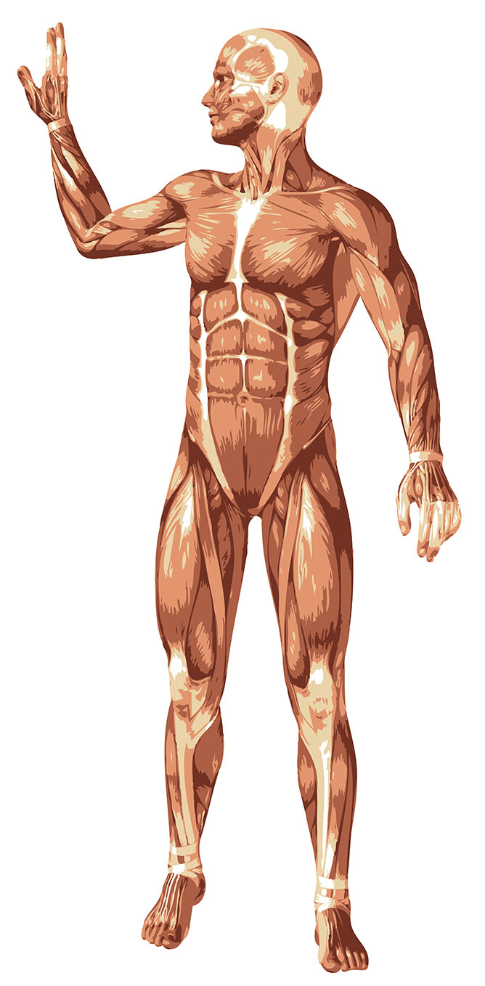

- What is the difference between a ligament and a tendon?

- There are three different muscle fibre types. Can you name them and link them to a type of activity?

- Can you identify the 2 different energy systems and explain the differences between them?

10.Can you match the definition to the component of fitness?

Muscular endurance
Coordination
Cardio-vascular endurance
Agility
Flexibility
Balance
Speed
Power

Component of fitness | Definition
 | The ability to sustain exercise for an extended period of time
 | The ability of a muscle or group of muscles to keep working over a longer period of time without tiring
 | The range of movement at a joint
 | The ability to keep the body stable whether still or moving
 | The ability to use two or more body parts at the same time
 | The rate at which you can complete a task or distance
 | The ability to produce a large force in a short amount of time. A combination of speed and strength
 | The ability to change direction quickly and under control

12. Imagine you are going back to your old primary school. Can you plan a fun physical
activity session for year 3 (aged 8)
Aim of the session:
By the end of the session participants will be able to…

Equipment needed

Health & safety considerations
Session Plan
Warm Up (10 minutes):

Session activities (30 minutes):

Cool down (10 minutes):

Additional comments/information:

