Subject level | A-level
Teacher | Zoe Bailey
Subject Context | The anatomy and physiology of the human body is integral to the study of sport. Understanding how our body operates allows us to begin to understand, control and improve human movement.
Deadline | Start of the 2021 academic year.
Resources required | Laptop (or pen and paper)  Internet (desirable not essential)  www.brianmac.co.uk  www.theeverleaner.com  Newspapers  TV news reports
Assignment details | Complete the nine tasks. There is an extension activity at the end should you wish to complete the assessment questions.

Task One – the Skeletal system
Label the skeleton using the bones below.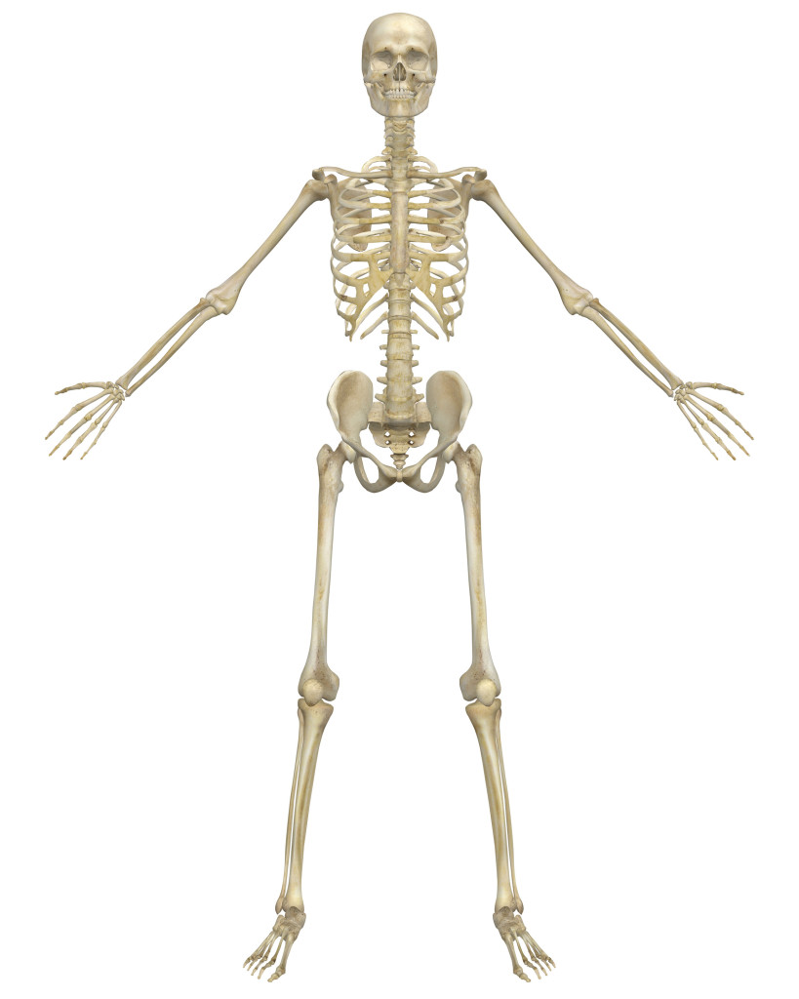

- Axial skeleton, i.e.
- cranium
- sternum
- ribs
- vertebral column
- cervical vertebrae
- thoracic vertebrae
- lumbar vertebrae
- sacrum
- coccyx
Appendicular skeleton, i.e.
- scapula
- clavicle
- humerus
- Ulna
- Radius
- Carpals
- Metacarpals
- phalanges
- ilium
- ischium
- pubis
- femur
- patella
- tibia
- fibula
- talus
- tarsals
- metatarsals

Task Two – The Vertebral column
Name/label the bones of the vertebral column & add any other relevant detail. Consider the structure and function.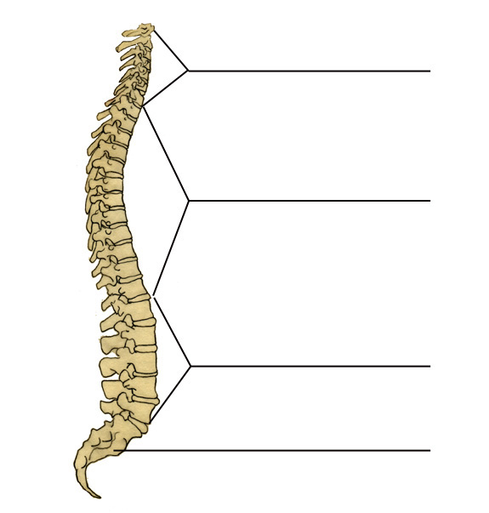
Task Three – Quick review:

1. Name three bones of the appendicular skeleton

2. Name three bones of the axial skeleton

3. What are the five key functions of the skeleton?

Task Four – Bones and joints of the skeleton
Research and answer the following questions:
- Give one function of a long bone and a different function of a flat bone.

- Aside from long and flat bones, name the other three types of bone

- Are the vertebrae: (tick the correct answer)
- Fixed joints
- Slightly moveable joints
- Freely moveable joints

- Give the other name for freely moveable joints

- Apart from ‘Hinge’ joint, name the other five different types of freely moveable joint.

Task Five – The Muscular system
Label the muscle diagram below using the muscles that operate around each of the named joints.
shoulder – deltoid, latissimus dorsi, pectoralis major, trapezius, teres major
elbow - biceps brachii, triceps brachii
radio-ulnar - pronator teres, supinator muscle
wrist - wrist flexors, wrist extensors
vertebral column - rectus abdominus, erector spinae group, internal and external obliques
hip – iliopsoas, gluteus maximus, gluteus medius, gluteus minimus, adductor longus, adductor brevis, adductor magnus
knee - rectus femoris, vastus medialis, vastus intermedius, vastus lateralis, biceps femoris, semimembranosus, semitendinosus
ankle - tibialis anterior, gastrocnemius, soleus

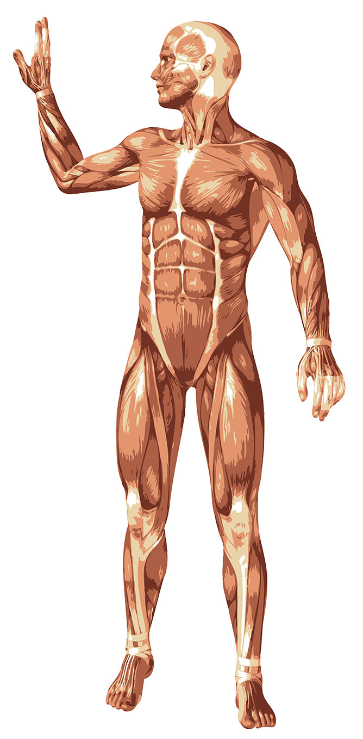

Task Six – The muscle
Answer the following questions:
- What is the difference between a ligament and a tendon?

- There are three different muscle fibre types. Identify their structure, function and the type of activity in which they would dominate.
Name | Structural characteristics (how they’re made) | Functional characteristics (what job they do) | Type of activity
Slow oxidative
(Type I)

Fast oxidative glycolytic (FOG)
(Type IIa)

Fast twitch glycolytic
(FTG)
(Type IIb or IIx)

Task Seven - The three Energy Systems
Research and complete the table below:
 | ATP-PC/Alactic System | Lactic Acid System | Aerobic System
Type of Reaction (Aerobic or Anaerobic)
Chemical/Substrate or Food fuel (what is broken down)
Amount of ATP produced
By-products
Additional Info

Task Eight – Sociological issues in sport
Write a 500 word report on the impact of Coronavirus on sport and physical activity in the UK. You may want to consider some, none, or all of the below bullet points:
- What sports/physical activities had their participation reduced, and why?
- What sports/physical activities saw an increase in participation and why?
- Restrictions on and differences between grassroots and elite sport
- Impact on training and competition
- The impact on mental health of restrictions in sport.

Task Nine - Optional Extension Activity – Assessment practice questions
These are from the A level textbook we use and have been taken from previous exam papers.
