Subject level | A-level
Teacher | Matt Smith
Subject context | The Economics team are really looking forward to teaching you in September. Economics is a very exciting and dynamic subject that is highly relevant to everything in your lives.  For most of you Economics will be an entirely new subject. The tasks provided below will prepare you with the basic knowledge to quickly engage with and understand the content taught on the economics course and develop the skills needed for you to think like an economist.
Deadline | Your first Economics lesson.
Estimated time required to complete activity | 3 hours
Submission instructions | Hand in during your first lesson.
Resources required | Laptop  Internet

Assignment details
TASK 1
As a good starting point, please watch the video below. It gives a good introduction to some of the things you will be studying over the next two years.
https://youtu.be/2Nq8LN3XGQA

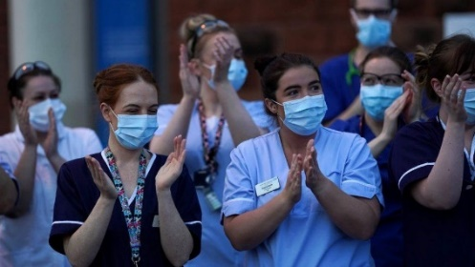
TASK 2
One of the topics we will study during the course is Labour Economics.
Why are footballers paid so much?
Why are some Key workers paid so little?
During the current pandemic, there have been lots of talk about why footballers are paid so much more than key workers. Key workers are the people who have helped to save lives and keep our lives functioning during the pandemic.
The graphic below shows how much some our key workers are paid.
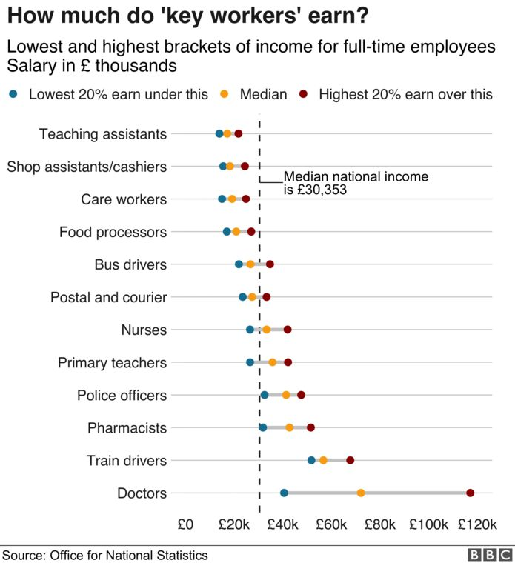
Why do you think footballers are paid so much more than key workers, such as shop workers or nurses?

The ONS (Office of National Statistics) estimates that the hourly pay for a care worker, cashier or shelf stacker is under £9 - which is more or less in line with the minimum wage (£8.72 for those aged 25 and over). But that falls short of what the Living Wage Foundation charity calculates is necessary to meet basic needs. It recommends £9.30 - or £10.75 in London.
Do you think these key workers should be paid more? If they are paid more then what impact would this have on the UK economy?

Some people argue that if footballers are paid less than this would actually mean less tax for the government and so the NHS would have less funds. Do you think this is a valid argument?

Here is an article that argues the case for there not being a pay cut for footballers.
https://www.bbc.co.uk/sport/football/52168692

TASK 3
It is a very interesting time to be studying Economics as the Economy is going to be in an unprecedented deep recession.
The Covid19 pandemic has greatly impacted on the economies of all countries. As a result of the lockdown the government has introduced a wide range of measures to help businesses and individuals. Do some research (the BBC website is good for this) and briefly write about three measures that the government has introduced since the lockdown.

1.

2.

3.

Task 4
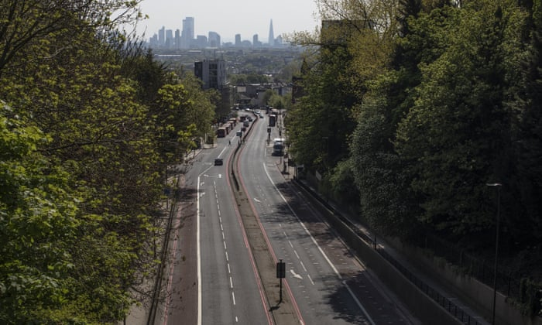
The improvement in air quality over the past month of the coronavirus lockdown has led to 11,000 fewer deaths from pollution in the UK and elsewhere in Europe, a study has revealed. Sharp falls in road traffic and industrial emissions have also resulted in 1.3m fewer days of work absence, 6,000 fewer children developing asthma, 1,900 avoided emergency room visits and 600 fewer preterm births, according to the Centre for Research on Energy and Clean Air.
While the pandemic continues to take a terrible toll – more than 220,000 deaths worldwide since the start of the year – the authors of the report say the response has offered a glimpse of the cleaner, healthier environment that is possible if the world shifts away from polluting fossil fuel industries.
Compared with the same period last year, levels of nitrogen dioxide have fallen by 40% while tiny particulate matter – known as PM2.5 – is down 10%, which means that people without Covid-19 can breathe easier. These two forms of pollution, which weaken the heart and respiratory system, are together normally responsible for about 470,000 deaths in Europe each year.
(Taken from The Guardian April 2020)
During your course, you will study a lot of Environmental Economics. Governments around the world will need to introduce policies to reduce global warming. Have a go at the task below.

What could the UK government do to reduce car usage?

What are the disadvantages of the policy? (think about who the losers would be)

Why might this policy not work? (This is evaluation)

Now choose another policy that the government could introduce in order to reduce global warming.
What is the policy?

What are the disadvantages of the policy?

Why might this policy not work?

